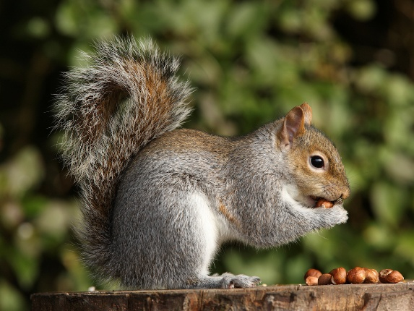

Squirrel Class Autumn 1 Newsletter
Dear Parents and Carers,
I hope you have had a wonderful summer holiday! We are so excited to start our learning journey together this September and have lots of exciting topics to cover.
PE Arrangements
Our timetabled PE day will be on a Tuesday. Please ensure that children bring their PE kit into school on this day so they are ready to participate fully in our sessions.
Homework Expectations
Weekly homework will focus on key skills in Maths. In addition to this, a homework topic sheet will be sent out via ClassDojo. The sheet will feature a selection of tasks, and children are asked to choose one task each week to complete alongside their weekly Maths. The sheet will also be stuck into their homework books along with their weekly maths homework. Homework will be sent out on a Friday and be due back in on a Thursday.
Regular completion of homework is extremely important in supporting your child’s learning journey. To encourage this, children who complete their homework consistently will be recognized and rewarded in class. For children who have not completed their homework they will have the opportunity to complete this on a Friday lunchtime in homework club.
Reading at Home & Reading Diaries
Reading remains one of the most important ways you can support your child’s learning. To ensure reading at home is properly recorded and supported, reading diaries need to be in school every day and taken home every night. Diaries will be checked and marked in and out each day to track progress, as regular home reading has immense benefits for comprehension, vocabulary, and overall confidence. Children need to be read with at home a minimum of 3 times a week.
"Adopt a Shelf" Class Reading Idea
To foster a love for reading across the class, we are introducing our new "Adopt a Shelf" idea! Each week, one child will have the opportunity to bring in a book (3 at the most!) from home to display on our special classroom shelf. They will get to show these to their classmates, explain why they like them, perhaps read a short section to the class, or even lend a favourite book to a friend.

Times Tables Practice
We will continue to use TT Rockstars to support the children’s recall of multiplication facts. Quick and accurate recall is essential for many areas of maths, particularly as we approach the year 4 multiplication check. Regular practice at home, even for short periods, makes a noticeable difference.
Curriculum Focus – Stones and bones!
This half term, our main History topic will be Who first lived in Britain? (Stone Age, Bronze Age and Iron Age) This exciting theme will link closely with our science where we are exploring rocks and our art where the children will get a chance to create their own cave paintings.
We are looking forward to seeing the children engage with this topic, as it offers plenty of opportunities for creativity, discussion, and cross-curricular learning.
Important dates
Wednesday 23rd September- History Man
Thursday 1st October- National Poetry Day
Tuesday 13th October-Parents Evening
Wednesday 14th October-Parents Evening
Friday 16th October-School Photographs
Friday 23rd October- Break up

I will be in class full time apart from every Thursday afternoon and Friday all day. I will be updating the class story on dojo weekly with any messages or updates about Squirrel class. If you have any concerns, please speak to me on the gate or via the office email (office@lindridge.worc.sch.uk).
Best wishes,
Mrs Murphy
Squirrel Class Teacher

