Our Lindridge EYFS Learning Journey
Possible Theme, Lines of Enquiry, matched with Children’s Interests
Nursery
Mini Me   | Time For Tea  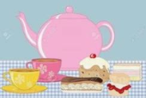 | All Aboard  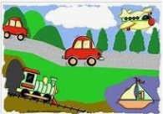 | Once Upon a Time…  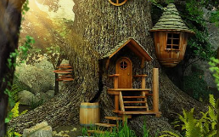 | Paws, claws and Nature Grows   | Pirates  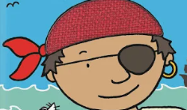
PSHE, Geog, Science, | PSHE, Geog, History, Science | PSHE, Geog, History, Science | PSHE, Geog, History, Science | PSHE, Geog, Science, | PSHE, Geog, Science, History
Autumn focus – seasonal changes |  | Winter focus – seasonal changes | Spring focus – seasonal changes |  | Summer focus – seasonal changes
The Big Question?
I wonder what makes me special? | What might happen at a tea party? | I wonder what we will see? | What can we learn from the Three Little Pigs? | How can we take care of living things? | What adventures can we have at sea?
Key Texts
Family and Me  Who Are You?  You’re so Amazing  All are Welcome  No-bot Robot  Owl Babies | The Tiger Who Came to Tea  Kipper’s Birthday  Tea Party Parade  I’m a little teapot  Dear Santa/Santa Post  Traditional Tale:  Goldilocks and the Three Bears | Meg’s Car  We Catch the Bus  Mr Gumpy’s Outing  Big Yellow Digger  Martha Maps it Out | The Do-it-yourself House that Jack Built  When I build with blocks  Miss Brick the Builder’s Baby  Traditional Tale: Three Little Pigs | Seed to Sunflower  The Girl who Loves Bugs  The Bad-Tempered Ladybird  Traditional Tale: Jack and the Beanstalk | Tiddler  Commotion in the Ocean  Mister Seahorse  Links with transition –  The Rock Pool (embracing change)  The Whale Who Wanted More (friendship)
Possible Theme, Lines of Enquiry, matched with Children’s Interests
Reception
All about me  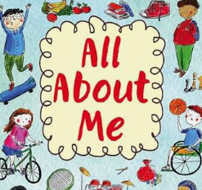 | Weather and Celebrations  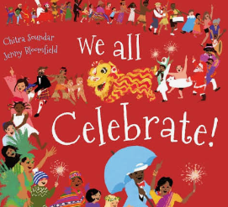 | Space and Transport  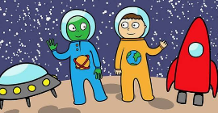 | Once Upon a Time | Walk on the Wild Side (Dinosaur/Zoo/Farm)  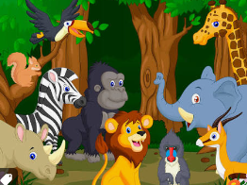 | Under the Sea  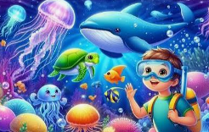
PSHE, Geog, Science, | PSHE, Geog, History, Science | PSHE, Geog, History, Science | PSHE, Geog, History, Science, | PSHE, Geog, Science, | PSHE, Geog, Science, History
Autumn focus – seasonal changes |  | Winter focus – seasonal changes | Spring focus – seasonal changes |  | Summer focus – seasonal changes
The Big Question?
Who am I? | How do we celebrate? | How far can we go on a journey? | Who’s afraid of the Big Bad Wolf? | Who owns these footprints? | What lives under the sea and how is it different?
Key Texts
Rosie’s Walk  Super Duper You  The Colour Monster | Leaf Man  Stanley’s Stick  Firework Poems  Santa Post/Dear Zoo  Jingle Bells  Traditional Tales: Hansel and Gretel/Gingerbread Man | Naughty Bus  Mrs Armitage on Wheels  Mae Among the Stars  A Little Blue Dot  The Hundred Decker Rocket | There’s not a wolf in this story  Traditional Tales:  The Three Little Wolves and the Big Bad Pig  Little Red | Dear Zoo  Farmer Duck  Farmyard Hullabaloo  Am I Yours?  How to look after your dinosaur | The Whale who wanted more  The Big Book of the Blue  Sharky McShark  Blob  Searching for Treasure  Links with transition –  The Whale who wanted more (kindness)
Curriculum Enrichment – Year A 2026/27
Pre-School and Reception
Autumn:  Godly Play each month  Parents come in for a phonics session  Little Owl Farm Park  Christingle Service at Church  Nativity either at Emma’s Farm/Church |  | Spring:  Godly Play each month  Woodland Walk |  | Summer:  Godly Play each month  All Things Wild  Sports’ Day  Water Play Day  Class Pets:  N – Frogs (hatch from tadpoles)  R – Ducklings (hatch from Eggs)
Curriculum Enrichment – Year B 2027/28
Pre-School and Reception
Autumn:  Godly Play each month  Visit to Tenbury Library  Christingle Service at Church  Nativity either at Emma’s Farm/Church |  | Spring:  Godly Play each month  Walk to Emma’s Farm  Fire Engine visit to school |  | Summer:  Godly Play each month  Bishopswood – minibeast/pondipping  Birmingham Sea Life Centre  Sports’ Day  Class Pets:  N – Butterflies (hatch from caterpillars)  R – Ducklings (hatch from Eggs)

Cultural Capital
Cultural capital is the essential knowledge that children need to prepare them for their future success. It is about giving children the best possible start to their
early education.
‘It is the role of the setting to ensure that children experience the awe and wonder of the world in which they live, through the seven areas of
learning.’ (143 p31 Ofsted Early Years Inspection Handbook, Sept 2019)
Festivals, Celebrations and Significant events
Autumn |  |  |  |  |  |  |  |  | Spring |  |  |  |  |  |  | Summer
Back to School / Settling In: September 2026.  Harvest Festival: September 2026.  Read a Book Day – 6th September 2026  Black History Month: October 2026.  National Poetry Day: 1st October 2026.  Diwali: 20 October 2026.  Apple Day: 21st October  Guy Fawkes Night (Bonfire Night): 5th November 2026.  Outdoor Classroom Day – 5th November  Anti-Bullying Week: 10th – 14th November 2026. |  |  |  |  |  |  |  |  | Big School’s Bird Watch – 5th January – 12th February  Storytelling Week – 30th January – 7th February  Children's Mental Health Week: Early February 2027.  Chinese New Year (Year of the Goat): 6th February 2027.  World Book Day: 4th March 2027.  International Women’s Day – 8th March 2027  British Science Week: 6th – 15th March 2027.  Easter Holidays: 25th March – 12th April 2027 |  |  |  |  |  |  | Earth Day: 22nd April 2027.  Maths & Statistics Awareness Month: April 2027.  National Children’s Gardening Day – 23rd – 31st May 2027  Healthy Eating Week: June 2027.  World Oceans Day: 8th June 2027
Parental Engagement Opportunities
Phonics Workshop – R  Harvest Assembly – N R  Grandparents’ Day – R  Parents’ Eve – N R |  |  | Maths Workshop – N R  Christmas Nativities – N R  Open Morning for prospective parents |  |  |  |  |  | Reading Café – N R  Parents’ STEM Challenge - R  Parents’ Eve - N R |  |  |  |  | Books and Bacon Butties (For Valentine’s Day) N R  Easter Bonnet Parade – N R  Phonics Workshop - N |  | Shared Forest School Experience – N R  Woodwork Workshop - R |  |  |  |  |  | End of Year Reports – N R  Parent Meeting for new families  Sports’ Days
Prime Areas
Personal, Social and Emotional Development
Intent
Children’s personal, social and emotional development (PSED) is crucial for children to lead healthy and happy lives and is fundamental to their cognitive development. Underpinning their personal development are the important attachments that shape their social world. Strong, warm and supportive relationships with adults enable children to learn how to understand their own feelings and those of others. Children should be supported to manage emotions, develop a positive sense of self, set themselves simple goals, have confidence in their own abilities, to persist and wait for what they want and direct attention as necessary. Through adult modelling and guidance, they will learn how to look after their bodies, including healthy eating, and manage personal needs independently. Through supported interaction with other children, they learn how to make good friendships, co-operate and resolve conflicts peaceably. These attributes will provide a secure platform from which children can achieve at school and in later life

Curriculum Goals
- To know how to be a good friend and take turns
- To look after and share resources and work as a team to tidy away
- To be independent and challenge ourselves, know about goals and how to set them
- To learn how to manage new situations, people and ideas with courage and interest
- To focus attention in a range of situations
- To show an ability to follow instructions involving several ideas or actions.
- Name feelings and emotions and self-regulate emotions
- To understand and follow school rules to keep ourselves and others safe
- To manage own personal hygiene
- To know how to be healthy and look after our bodies

Skills – communicate feelings and emotions, form relationships with others, co operate, negotiate, set goals, persist, wait, focus attention, manage own needs, self-regulate

ELG - Self Regulation  - Show an understanding of their own feelings and those of others, and begin to regulate their behaviour accordingly.  - Set and work towards simple goals, being able to wait for what they want and control their immediate impulses when appropriate.  - Give focused attention to what the teacher says, responding appropriately even when engaged in activity, and show an ability to follow instructions involving several ideas or actions. |  |  |  |  |  |  |  |  |  | ELG – Managing Self  - Be confident to try new activities and show independence, resilience and perseverance in the face of challenge.  - Explain the reasons for rules, know right from wrong and try to behave accordingly.  - Manage their own basic hygiene and personal needs, including dressing, going to the toilet and understanding the importance of healthy food choices. |  |  |  |  |  |  | ELG – Building Relationships  - Work and play cooperatively and take turns with others.  - Form positive attachments to adults and friendships with peers.  - Show sensitivity to their own and to others’ needs.    EEF Research supported
Scheme – PHSE – Jigsaw - Nursery
Being me in my world Who am I and how  do I do it? |  |  |  | Celebrating difference  Respect for similarities and difference.  Anti bullying and  being unique. |  |  |  |  |  | Dream and goals Aspirations how to achieve goals and understanding the  emotions that go with  this. |  |  |  |  | Healthy me  Being and keeping  safe and healthy. |  | Relationships  Building positive  healthy relationships. |  |  |  |  | Changing me  Coping positively  with change.
Scheme – PHSE – Jigsaw - Nursery
Being me in my world  Who am I and how  do I do it?  -Self-identity  -Understanding  feelings  -Being in a classroom  -Being gentle  -Rights and  responsibilities |  |  |  | Celebrating difference  Respect for similarities and difference. Anti bullying and being unique  -Identifying talents  -Being special  -Families  -Where we live  -Making friends  -Standing up for yourself |  |  |  |  |  | Dream and goals Aspirations how to achieve goals and understanding the  emotions that go with  this  - Challenges  -Perseverance  -Goal-setting -Overcoming obstacles  -Seeking help  -Jobs  -Achieving goals |  |  |  |  | Healthy me  Being and keeping safe and healthy - Exercising bodies  -Physical activity  -Healthy food  -Sleep  -Keeping clean  -Safety |  | Relationships  Building positive healthy relationship  - Family life  -Friendships  -Breaking friendships  -Falling out  -Dealing with bullying  -Being a good friend |  |  |  |  | Changing me  Coping positively with change  -Bodies  -Respecting my body  -Growing up  -Fun and fears  -Celebrations  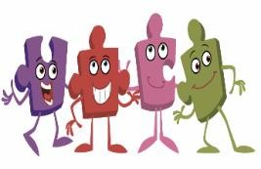
Physical Development Intent and Curriculum Goals
Intent
Physical activity is vital in children’s all-round development, enabling them to pursue happy, healthy and active lives. Gross and fine motor experiences develop incrementally throughout early childhood, starting with sensory explorations and the development of a child’s strength, co-ordination and positional awareness through tummy time, crawling and play movement with both objects and adults. By creating games and providing opportunities for play both indoors and outdoors, adults can support children to develop their core strength, stability, balance, spatial awareness, co-ordination and agility. Gross motor skills provide the foundation for developing healthy bodies and social and emotional well-being. Fine motor control and precision helps with hand-eye co-ordination, which is later linked to early literacy. Repeated and varied opportunities to explore and play with small world activities, puzzles, arts and crafts and the practice of using small tools, with feedback and support from adults, allow children to develop proficiency, control and confidence.

Curriculum Goals
- To be able to get changed for PE independently
- To be able to engage in team games demonstrating ball skills
- To be able to demonstrate developed balance and co ordination
- To move in a variety of ways and negotiate space
- To be able to ride a range of scooters and a balance bike
- To be able join a sequence of movements to be able to perform a simple dance or gymnastics routine
- To be able to say how to keep themselves healthy and happy
- To describe the effects of exercise on our bodies
- To be able to hold a pencil using a tripod grip
- To draw pictures including people and landscapes with added detail
- To be able to use cutlery effectively
- To be able to use scissors and other tools effectively and safely

Skills – control, confidence, fine motor skills, gross motor skills, core strength, co-ordination, positional and spatial awareness

ELG – Gross Motor Skills  - Negotiate space and obstacles safely, with consideration for themselves and others.  - Demonstrate strength, balance and coordination when playing.  - Move energetically, such as running, jumping, dancing, hopping, skipping and climbing. |  |  |  |  |  |  |  |  |  |  |  |  |  |  | ELG – Fine Motor Skills  - Hold a pencil effectively in preparation for fluent writing – using the tripod grip in almost all cases.  - Use a range of small tools, including scissors, paintbrushes and cutlery.  Begin to show accuracy and care when drawing.
Scheme - Gross Motor Skills – Get Set 4 PE
Forest School  Get Set 4 PE |  |  |  | Forest School  Get Set 4 PE |  |  |  |  |  | Forest School  Get Set 4 PE |  |  |  |  | Forest School  Get Set 4 PE |  | Forest School  Get Set 4 PE |  |  |  |  | Forest School  Get Set 4 PE
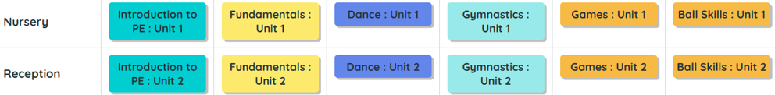
Scheme - Fine Motor Skills – Squiggle Set
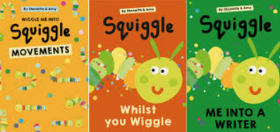
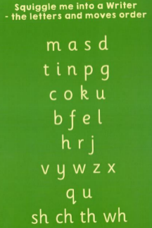
Nursery 2-3yrs
Mini Squiggles

Nursery 3-4yrs
Squiggle While You Wiggle

Reception
Squiggle me into a writer

All – Dough Disco
Squiggle Whilst You Wiggle:
From 2 years old, we follow the Squiggle Whilst you Wiggle program to teach mark-making, which then progresses into writing as they move through our Early Years. Squiggle Whilst You Wiggle is an early writing program created by a Shonette Bason-Wood, who also created the program Dough Disco. Squiggle Whilst You Wiggle incorporates dance, music and large movements to help children develop the fine muscle control they need for writing. Each week they will learn a new gross motor movement to a piece of music while dancing along to the music. The children then transfer these movements to floor level and use writing tools (crayons) to make marks on paper. These sessions are great fun, but most importantly help our children to be confident mark makers. Once children join Reception they will progress through the letters as part of the program.
Squiggle Whilst You Wriggle recap – weeks 1 and 7 |  |  |  | Squiggle Whilst You Wriggle recap – weeks 8 and 9  Squiggle Me Into A Writer  Gross Motor: feel letters, big movements with ribbons etc, sand.  Fine Motor: Using whiteboard pencils and boards in lizard position, learn letters: m a s d  t I n p g  c o k u  b f e l  h r j |  |  |  |  |  | Squiggle Me Into A Writer  Gross Motor: feel letters, big movements with ribbons etc, sand.  Fine Motor: Using whiteboard pencils and boards in lizard position, learn letters:  v y w z x  q u  sh ch th wh  Recap letters. |  |  |  |  | Squiggle Me Into A Writer  Gross Motor: feel letters, big movements with ribbons etc, sand.  Fine Motor: Using whiteboard pencils and boards in lizard position. Recap letters. |  | Squiggle Me Into A Writer  Gross Motor: feel letters, big movements with ribbons etc, sand.  Fine Motor: Sitting at tables and writing letters in books. Recap letters and write simple/red words. |  |  |  |  | Squiggle Me Into A Writer  Gross Motor: feel letters, big movements with ribbons etc, sand.  Fine Motor: Sitting at tables and writing letters in books. Recap letters and write simple/red words.
Communication and Language Intent and Curriculum Goals
Intent
The development of children’s spoken language underpins all seven areas of learning and development. Children’s back-and forth interactions from an early age form the foundations for language and cognitive development. The number and quality of the conversations they have with adults and peers throughout the day in a language-rich environment is crucial. By commenting on what children are interested in or doing, and echoing back what they say with new vocabulary added, practitioners will build children's language effectively. Reading frequently to children, and engaging them actively in stories, non-fiction, rhymes and poems, and then providing them with extensive opportunities to use and embed new words in a range of contexts, will give children the opportunity to thrive. Through conversation, story-telling and role play, where children share their ideas with support and modelling from their teacher, and sensitive questioning that invites them to elaborate, children become comfortable using a rich range of vocabulary and language structures.

Curriculum Goals
- To talk confidently to adults and peers in well-formed sentences about their learning and interests
- Use talk to interact and negotiate as part of extended conversations
- To ask questions to find out more and express my point of view
- To use an increasingly diverse range of vocabulary in meaningful contexts
- To use a range of language structures
- To actively join in with stories and retell known stories and rhymes
- To engage in back-and-forth conversations using the correct tenses with familiar adults and peers
- To develop an increasing confidence to share learning with others, including a range of audiences
- To interact with members of the general public and visitors when on trips or during special event days
- To say hello in a range of languages

Skills – interact, converse, listen, engage, respond, elaborate, tell stories, role play, express ideas and feelings

ELG - Listening Attention and Understanding  - Listen attentively and respond to what they hear with relevant questions, comments and actions when being read to and during whole class discussions and small group interactions.  - Make comments about what they have heard and ask questions to clarify their understanding.  - Hold conversation when engaged in back-and-forth exchanges with their teacher and peers.  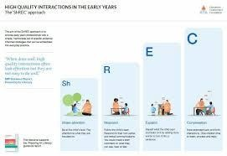  SHREC Research Supported |  |  |  |  |  |  |  |  |  |  |  |  |  |  | ELG - Speaking  - Participate in small group, class and one-to-one discussions, offering their own ideas, using recently introduced vocabulary.  - Offer explanations for why things might happen, making use of recently introduced vocabulary from stories, non-fiction, rhymes and poems when appropriate.    - Express their ideas and feelings about their experiences using full sentences, including use of past, present and future tenses and making use of conjunctions, with modelling and support from their teacher.  Voice 21 Research Supported
Language Screening Tools and Interventions
Nursery:  Every Child a Talker helps to identify pre-school and primary school children who are experiencing barriers to speech and language development so that they can be supported early in their education journey.  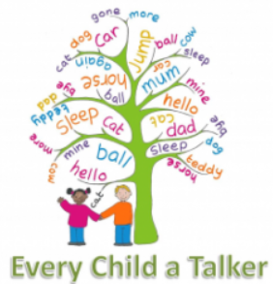 |  |  |  |  |  |  |  |  |  |  |  |  |  |  | Reception:  Every Child a Talker is an Early Indentification Profile enabling schools to identify and support children who have mild to moderate speech and language needs using a standardised screening assessment and tiered levels of intervention support.
Oracy Nursery
Cognitive |  |  |  |  | Physical |  |  |  |  |  |  |  |  |  | Social and Emotional |  |  |  |  |  | Linguistic
- Retell a simple event in the correct order  - Use talk to pretend, predict and recall |  |  |  |  | - Speak so that others can hear.  - Look at who they are talking to.  - Show others what they are talking about. |  |  |  |  |  |  |  |  |  | - Take turns talking with one other person  - Listen to what is being said  - Use talk to share ideas with friends |  |  |  |  |  | - Link thoughts together using and or because  - Use vocabulary based on things that are important to them  - Show an understanding of who, what, where, when and why questions  - Use a range of tenses
Oracy Reception
Cognitive |  |  |  |  | Physical |  |  |  |  |  |  |  |  |  | Social and Emotional |  |  |  |  |  | Linguistic
- To ask questions  - To wonder about ideas  - To use because to develop their ideas  - Describe events that have happened in detail |  |  |  |  | - To use gesture to support meaning in play.  - To speak audibly so they can be heard and understood |  |  |  |  |  |  |  |  |  | - To listen to others  - To take turns to speak |  |  |  |  |  | - To use talk in play to practice new vocabulary  - To join phrases with words such as ‘if’ ‘because’ ‘so’ ‘could’ ‘but’
Specific Areas
Literacy Intent and Curriculum Goals
Intent
It is crucial for children to develop a life-long love of reading. Reading consists of two dimensions: language comprehension and word reading. Language comprehension (necessary for both reading and writing) starts from birth. It only develops when adults talk with children about the world around them and the books (stories and non-fiction) they read with them, and enjoy rhymes, poems and songs together. Skilled word reading, taught later, involves both the speedy working out of the pronunciation of unfamiliar printed words (decoding) and the speedy recognition of familiar printed words. Writing involves transcription (spelling and handwriting) and composition (articulating ideas and structuring them in speech, before writing)

Curriculum Goals
- To read phonics books with fluency and expression and talk about what they have read, asking appropriate questions
- To be able to decode unfamiliar words with confidence
- To know how to retrieve information from books
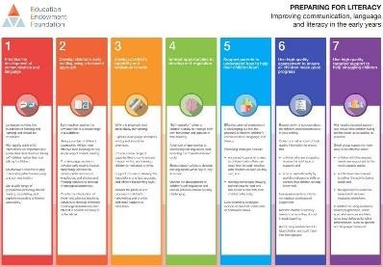
- To enjoy reading and listening to stories for pleasure
- To know the characters and settings from a range of familiar stories
- To be able retell three traditional tales and recite five nursery rhymes
- To be able to make predictions of what might happen in a story
- To retell familiar stories in the right order including key vocabulary
- To be confident to ‘have a go’ at writing words that cannot be phonetically decoded
- To write simple sentences and phrases that I can read and that can be read by others
- To enjoy writing for a range of purposes including drawing club EEF Research Supported

Skills – comprehension of language, spoken and written, recognising rhyme, repetition, alliteration, oral blending and segmenting, fluency in reading and decoding, fine motor skills for writing, composition, transcription, re reading for meaning

ELG: Comprehension  - Demonstrate understanding of what has been read to them by retelling stories and narratives using their own words and recently introduced vocabulary  - Anticipate – where appropriate – key events in stories  - Use and understand recently introduced vocabulary during discussions about stories, non-fiction, rhymes and poems and during roleplay. |  |  |  |  |  |  |  |  |  | ELG: Word Reading  - Children at the expected level of development will: - Say a sound for each letter in the alphabet and at least 10 digraphs  - Read words consistent with their phonic knowledge by soundblending  - Read aloud simple sentences and books that are consistent with their phonic knowledge, including some common exception words. |  |  |  |  |  |  | ELG: Writing  - Children at the expected level of development will  - Write recognisable letters, most of which are correctly formed  - Spell words by identifying sounds in them and representing the sounds with a letter or letters  - Write simple phrases and sentences that can be read by others
Phonics
Reading  The children:  - Learn 44 sounds and the corresponding letters/letter groups using simple picture prompts – see below  - Learn to read words using Fred talk and sound blending  - Read from a range of storybooks and non-fictions books matched to their phonic knowledge  - Work well with partners  - Develop comprehension skills in stories by answering 'Find It' and 'Prove It' discussion questions |  |  |  |  |  |  |  |  |  | Writing  The children:  - Learn to write and form the letters/letter groups which represent the 44 sounds with the help of fun phrases  - Learn to write words by using Fred Talk  - Learn to build sentences by practising sentences out loud before they write |  |  |  |  |  |  | Talking  The children work in pairs so that they:  - Answer every question  - Practise every activity with their partner  - Take turns in talking and reading to each other  - Develop ambitious vocabulary
Set 1 Sounds  m a s d t, i n p g o, c k u b, f e l h sh, r j v w, th z ch qu x ng nk |  |  |  |  |  |  |  |  |  | Set 2 Sounds  ay, ee, igh, ow (as in blow), oo (as in zoo) oo (as in look), ar, or, air, ir, ou (as in out), oy |  |  |  |  |  |  | Set 3 Sounds.  - ea (as in tea)  - oi (as in spoil)  - a–e (as in cake)  - i–e (as in smile)  - o–e (as in home)  - u–e (as in huge)  - aw (as in yawn)  - are (as in care)
Nonsense words/Alien words - What a load of nonsense!
As well as learning to read and blend real words children will have plenty of opportunities to apply their sound recognition skills on reading ‘Nonsense words’. These words will also feature heavily in the Year One Phonics Screening check in the summer term. These words provide endless opportunities for children to apply and practice their thinking in a range of different contexts.
Children will be introduced to ‘Ditty books’ when they successfully begin to read single words. The short vowels should be kept short and sharp. Children use sound-blending (Fred Talk) to read short ditties.
Within all the RWI sessions/books children will be exposed to red and green words to learn to help them to become speedy readers. Red words are words that are not easily decodable ("You can't Fred a red") and challenge words to extend children’s vocabulary. Green words are linked to the sounds they have been learning and are easily decodable.
Order of Story books:
Children will hopefully follow the order listed below. The expectation is that all children will leave Year One as confident, speedy readers, ready to take on the challenges of Year Two. However, some children may need extra support and your teacher will talk to you about this.
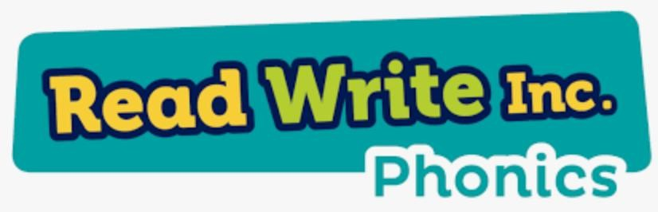
Books Year Group Expectations
Ditty 1-10 Reception
Green 1-10 Reception
Purple 1-10 Reception
Pink 1-10 Reception/Year One

Reading – Writing – Oracy Drivers
  Nursery  Story Dough is an immersion into the magic world of story dreaming with small groups of children. It is best used as a 'pop-up' in the flow of the day and its joy can be shared with children as little or often as you want.  Using the medium of playdough, Story Dough tips children into landscape of nonsense, rhyme, language, delicious vocabulary, mark making, make-believe, mathematics and story. It is unlimited in where the adventure with Story Dough can take the children. |  |  |  |  |  |  |  |  |  |  |  |  |  |  | 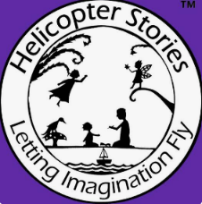  Reception  The rationale behind "Helicopter Stories" is to foster a child-led, inclusive learning environment where every child's voice is valued. By transcribing stories verbatim and immediately acting them out, it transforms abstract language into a tangible, physical experience, boosting confidence, communication, and empathy among early years children. [1  The Core Philosophies  - Empowering the Child's Voice: Adults do not correct the grammar, structure, or plot. By scribing exactly what the child says (word for word), educators validate the child's thought processes and show that their ideas are inherently worthy.  - Bridging Play and Storytelling: Fantasy play is the foundation of early education. Acting out stories allows children to physically inhabit their own narratives and explore social roles in a safe, controlled way.  - Building a Community of Listeners: Gathering the whole class around a taped-out "stage" teaches children patience, active listening, and respect. It shifts the focus from an adult-led curriculum to one driven by peer engagement.  Key Benefits  - Inclusive for All Abilities: For children with special educational needs (SEND), EAL (English as an Additional Language), or those who are non-verbal, dictating a story removes the barrier of writing and provides a way to communicate their inner world.  - Encourages Literacy: Children naturally absorb sentence structure, vocabulary, and narrative concepts without the pressure of formal writing exercises.  - Develops Social and Emotional Skills: Children learn to wait their turn, negotiate roles, and handle resilience when a peer’s story doesn't go the way they hoped
Mathematics Intent and Curriculum Goals
Intent
Developing a strong grounding in number is essential so that all children develop the necessary building blocks to excel mathematically. Children should be able to count confidently, develop a deep understanding of the numbers to 10, the relationships between them and the patterns within those numbers. By providing frequent and varied opportunities to build and apply this understanding – such as using manipulatives, including small pebbles and tens frames for organising counting – children will develop a secure base of knowledge and vocabulary from which mastery of mathematics is built. In addition, it is important that the curriculum includes rich opportunities for children to develop their spatial reasoning skills across all areas of mathematics including shape, space and measures. It is important that children develop positive attitudes and interests in mathematics, look for patterns and relationships, spot connections, ‘have a go’, talk to adults and peers about what they notice and not be afraid to make mistakes.

Curriculum Goals
- To confidently count to 20 and beyond
- To match numerals with number values and write numbers to 10
- To be able to count by subitising and using 1-1 correspondence
- To have an in-depth knowledge of numbers to 10, including number bonds, odd and even numbers and doubles
- Compare quantities up to 10 in different contexts, recognising when one quantity is greater than, less than or the same as the other quantity.
- To name 2D and 3D shapes and make patterns
- To be able to have a go at solving mathematical problems and not to be afraid to make mistakes
- To be able to explain mathematical thinking and ideas using mathematical language and concepts
- To know the days of the week, months of the year and the seasons
- To be able to simply compare the weight, length and capacity of an object
- To know that money is used to buy things

Skills – counting, representing, subitising, comparing, creating patterns, partitioning, combining, sharing, measuring, describing, exploring, manipulating, reasoning, recall, abstract thinking.

ELG: Number  - Have a deep understanding of number to 10, including the composition of each number  - Subitise (recognise quantities without counting) up to 5  - Automatically recall (without reference to rhymes, counting or other aids) number bonds up to 5 (including subtraction facts) and some number bonds to 10, including double facts. |  |  |  |  |  |  |  |  |  |  |  |  |  |  | ELG: Numerical Patterns  - Verbally count beyond 20, recognising the pattern of the counting system  - Compare quantities up to 10 in different contexts, recognising when one quantity is greater than, less than or the same as the other quantity  - Explore and represent patterns within numbers up to 10, including evens and odds, double facts and how quantities can be distributed equally.
Mastering Number  Pupils will build on previous experiences of number from their home and nursery environments, and further develop their subitising and counting skills. They will explore the composition of numbers within 5. They will begin to compare sets of objects and use the language of comparison.    EEF Research Supported |  |  |  |  |  |  |  |  |  | Mastering Number  Pupils will continue to develop their subitising and counting skills and explore the composition of numbers within and beyond 5. They will begin to identify when two sets are equal or unequal and connect two equal groups to doubles. They will begin to connect quantities to numerals.   |  |  |  |  |  |  | Mastering Number  Pupils will consolidate their counting skills, counting to larger numbers and developing a wider range of counting strategies. They will secure knowledge of number facts through varied practice.  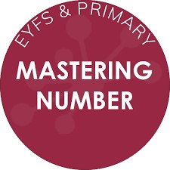
Nursery White Rose Maths Overview
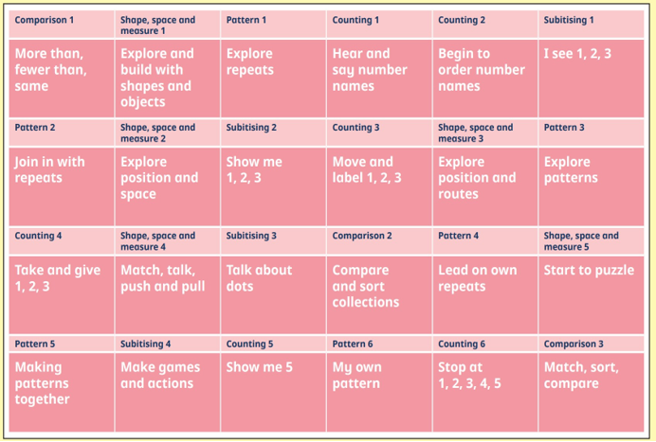
Reception White Rose Maths Overview
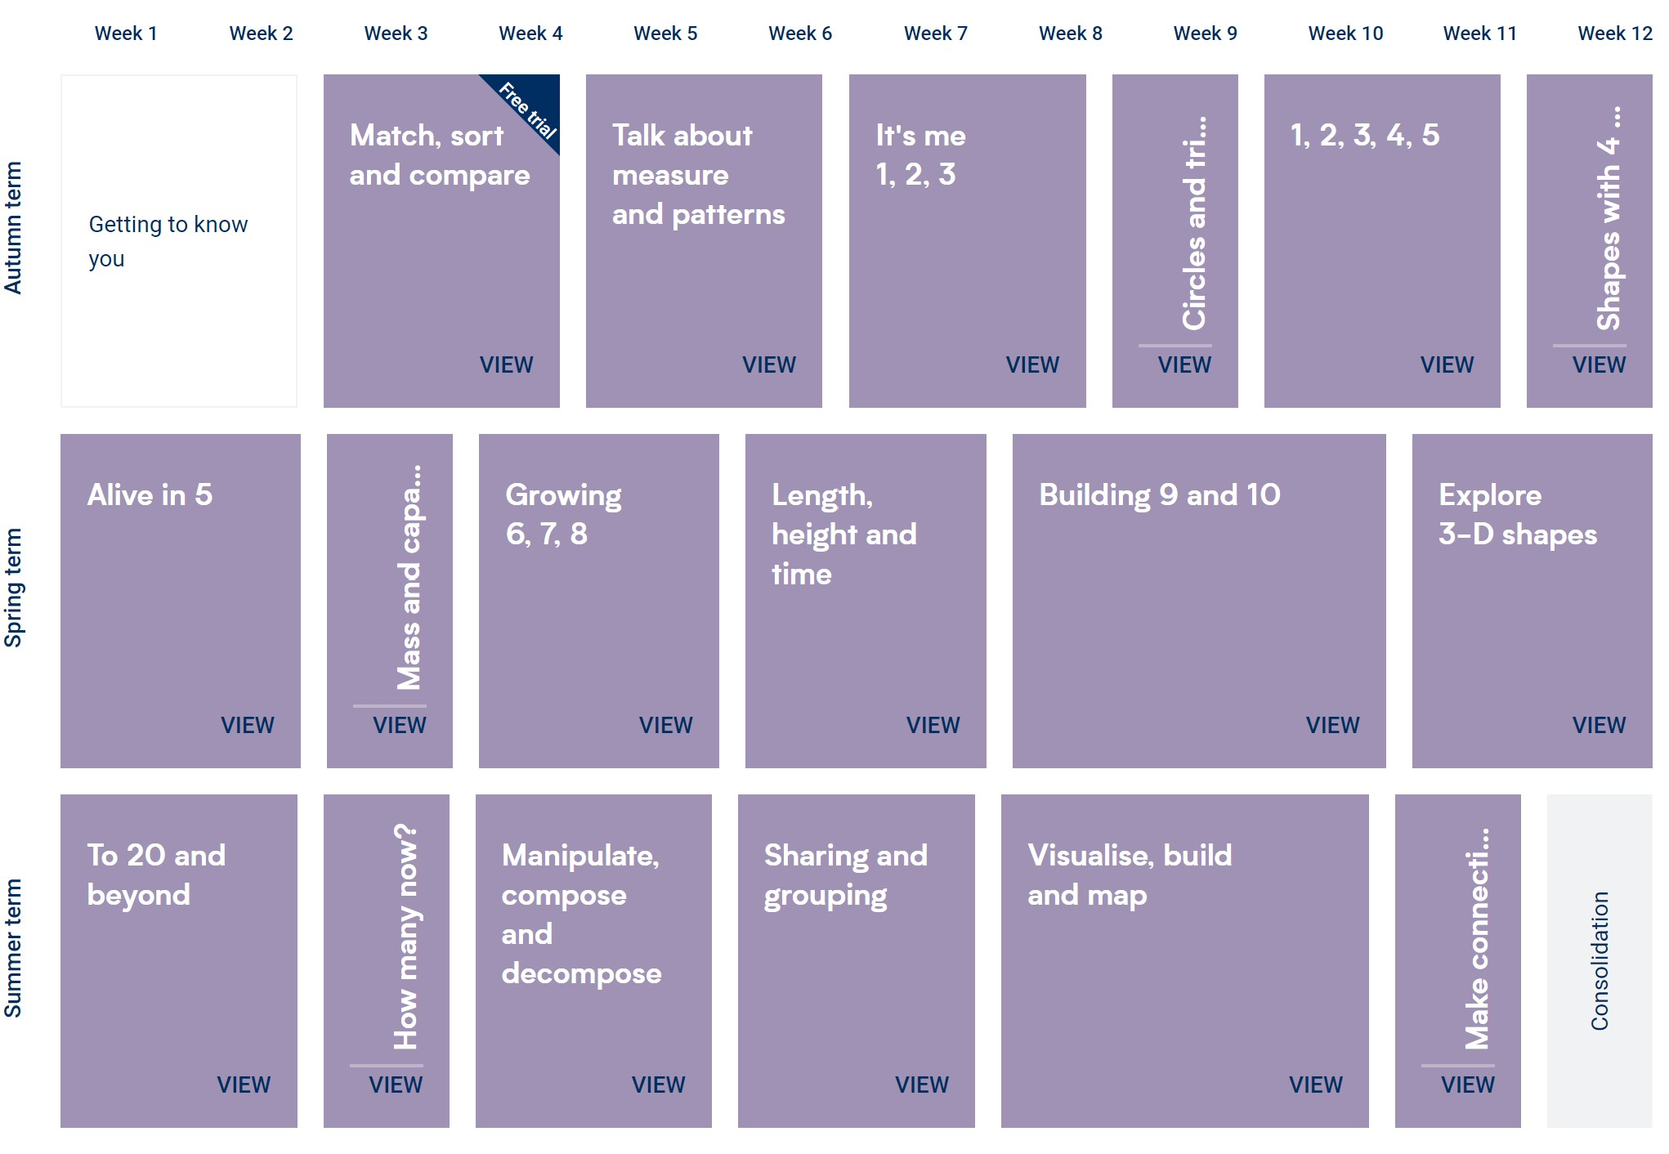

Specific Areas
Understanding the World - Intent and Curriculum Goals
Intent
Understanding the world involves guiding children to make sense of their physical world and their community. The frequency and range of children’s personal experiences increases their knowledge and sense of the world around them – from visiting parks, libraries and museums to meeting important members of society such as police officers, nurses and firefighters. In addition, listening to a broad selection of stories, nonfiction, rhymes and RE / Festivals poems will foster their understanding of our culturally, socially, technologically and ecologically diverse world. As well as building important knowledge, this extends their familiarity with words that support understanding across domains. Enriching and widening children’s vocabulary will support later reading comprehension.

Curriculum Goals
- To be able to talk about Cranham Primary school and the local area
- To draw a simple map of places that I know
- To explain some similarities and differences between the natural world making comparisons with Africa and Antarctica • To know about cultures and traditions from other countries
- To understand that people have different values and beliefs and be respectful of these
- To know some Christian values, stories and traditions and why they are important
- To know about other religions
- To talk about my past using appropriate vocabulary
- To talk about how life has changed from when my parents/ grandparents were little
- To talk about sequences such as the school day and be able to sequence stories
- To talk about famous people from the past
- To observe and comment on the differences in the seasons and weather and compare to other hot and cold countries
- To carry out simple scientific investigations to answer a question and understand some important processes and changes
- To explore a range of materials and states of being and say how they have changed over time
- To know that plants grow from a seed and discuss changes
- To know what plants need to grow
- To know that animals live in different habitats
- To begin to understand and ask questions about our natural world

Skills – explain, predict, explore, investigate, respect, be curious, make connections, try things in different was, question, apply skills, concentrate
ELG: Past and Present  - Talk about the lives of the people around them and their roles in society  - Know some similarities and differences between things in the past and now, drawing on their experiences and what has been read in class  - Understand the past through settings, characters and events encountered in books read in class and storytelling. |  |  |  |  |  |  |  | ELG: People, Culture and Communities  - Describe their immediate environment using knowledge from observation, discussion, stories, nonfiction texts and maps  - Know some similarities and differences between different religious and cultural communities in this country, drawing on their experiences and what has been read in class  - Explain some similarities and differences between life in this country and life in other countries, drawing on knowledge from stories, non-fiction texts and when appropriate – maps. |  |  |  |  |  |  |  |  |  |  |  | ELG: The Natural World  - Explore the natural world around them, making observations and drawing pictures of animals and plants  - Know some similarities and differences between the natural world around them and contrasting environments, drawing on their experiences and what has been read in class.  - Understand some important processes and changes in the natural world around them, including the seasons and changing states of matter.
Significant People from the Past
Nursery – King Charles III |  |  |  |  |  |  |  |  |  |  |  |  | Reception – Mae Jemison, Neil Armstrong, Guy Fawkes
Changing Seasons
Exploring changing seasons in Early Years education plays a crucial role in the overall development of children. Here are some reasons why exploring changing seasons is beneficial for children’s development:
- Sensory Stimulation: Each season brings a unique set of sensory experiences. Exploring the sights, sounds, textures, and even smells associated with different seasons provides rich sensory stimulation. This, in turn, aids in the development of the child’s sensory processing abilities.
- Cognitive Development: Observing and understanding the changes in nature across seasons promotes cognitive development. Children learn to recognise patterns, make comparisons, and categorise information. This cognitive engagement lays the foundation for critical thinking skills.
- Language Acquisition: Describing the characteristics of each season, discussing weather changes, and using seasonal vocabulary during activities contribute to language development. Children expand their vocabulary and learn to articulate their observations and experiences.
- Emotional Well-Being: Connecting with nature and experiencing the beauty of changing seasons has positive effects on emotional well-being. Outdoor activities and nature walks provide opportunities for relaxation, reducing stress, and promoting a sense of calm and happiness.
- Adaptability and Resilience: Experiencing seasonal changes teaches children about adaptability. Witnessing the natural world go through cycles helps them understand the concept of change and builds resilience in the face of transitions.
- Environmental Awareness: Understanding seasonal changes fosters environmental awareness from an early age. Children develop a sense of responsibility and appreciation for the natural world, laying the groundwork for future environmental consciousness.
- Cultural Understanding: Exploring changing seasons allows for the introduction of cultural celebrations and traditions associated with each season. This exposure broadens children’s cultural understanding and appreciation for diversity.
- Curiosity and Inquiry Skills: The ever-changing nature of seasons naturally sparks curiosity. Encouraging children to ask questions, explore, and seek answers cultivates a mindset of inquiry and lifelong learning.

Mini Me  -All about me and my family  -When I was a baby  --Simple body parts  --Introduction to the 5  senses |  | Time for Tea  -Investigations – changes of state – baking/ jelly  Ogden Trust Investigations:  Tea Time around the World  Goldilocks and the three bears |  |  |  |  | All Aboard  -Pushes and Pulls  -Wind up toys  Ogden Trust Investigation:  The Wheels on the Tuk Tuk |  |  |  |  | Once Upon a Time  Ogden Trust Investigation: Three Little Pigs  Work with Reception buddies |  |  |  |  |  |  | Paws, Claws and Nature Grows  Life cycles  -Caterpillars  -Growing -beanstalks and sunflowers  -Minibeast habitats/Bug Hotels |  |  |  |  | Pirates  -Floating and sinking
All About Me  -All about me and my school  -Human life cycles and how we grow and change  -Healthy eating  -Hygiene  -5 senses  Ogden Trust Investigation: Elmer the Elephant |  | Weather and Celebrations  -Light and Dark  -Nocturnal animals  Investigations:  -Changes in state  freezing and melting ice  -Melting chocolate for  forest fun snacks  -Shadow  investigations |  |  |  |  | Space and Transport  -The solar system  -Super Scientist  investigations (to be  decided)  Ogden Trust Investigation:  Astro Girl |  |  |  |  | Once Upon a Time  Ogden Trust Investigation: Three Little Pigs |  |  |  |  |  |  | Walk on the Wild Side  Mother animals and their young  -Life cycles – ducklings  -Class wormery  -Growing vegetables |  |  |  |  | Under the Sea  -Making sea water and comparing salty water with fresh water  -Floating and sinking in salt water and fresh water  -What makes bubbles?  -What happens when we make waves?
History/Geography
Mini Me  My Nursery Environment |  | Time for Tea  Birthdays, getting older and changes from being a baby  Famous person study – King Charles III |  |  |  |  | All Aboard  Old and new vehicles  My local area |  |  |  |  | Once Upon a Time  Sequencing events, chronology |  |  |  |  |  |  | Paws, Claws and Nature Grows  Human and physical features of a garden |  |  |  |  | Pirates  Making treasure maps  Knowing difference between land and sea
All About Me  Life Cycles  How I have changed  Where I live  My school community and local community |  | Weather and Celebrations  Famous Person study – Guy Fawkes  Countries of celebrations |  |  |  |  | Space and Transport  Contrasting localities |  |  |  |  | Once Upon a Time  Explore Forest environment and create maps  Give directions  Compare story book houses with houses in our locality |  |  |  |  |  |  | Walk on the Wild Side  Farming in the past  Reading and drawing maps  Human and physical features of a farm |  |  |  |  | Under the Sea  Seaside holidays in the past  Seas and oceans  Seasides are found  on the coast  Physical and human features of seaside locations
RE – Worcestershire Agreed Syllabus
Being special – where do we belong? |  | Incarnation – why do Christians perform  nativity plays |  |  |  |  | What times or stories are special and why? |  |  |  |  | Salvation – why do Christians put a cross in the Easter garden? |  |  |  |  |  |  | God and creation – why is the word God so important to Christians? |  |  |  |  | What places are special and why?
Expressive Arts and Design – Intent and Curriculum Goals
Intent
The development of children’s artistic and cultural awareness supports their imagination and creativity. It is important that children have regular opportunities to engage with the arts, enabling them to explore and play with a wide range of media and materials. The quality and variety of what children see, hear and participate in is crucial for developing their understanding, self-expression, vocabulary and ability to communicate through the arts. The frequency, repetition and depth of their experiences are fundamental to their progress in interpreting and appreciating what they hear, respond to and observe.

Curriculum Goals
- To know how to mix primary colours to make secondary colours
- To make detailed observational drawings and paintings of people, landscapes and animals
- To select the appropriate tools and materials required for given tasks
- To be inspired by the work of famous artists
- To make a model using malleable materials such as clay
- To know how to join materials such as paper card and junk model materials
- To be able to design, plan and make a model using construction or junk modelling materials
- To be able to confidently sing a range of familiar songs and nursery rhymes
- To be able to keep a beat by clapping and using musical instruments
- To be able join a sequence of movements to be able to perform a simple dance routine
- To engage in creative role play and small world play using props to act out their own and familiar stories

Skills – imagine, create, explore, observe, participate, express, communicate, interact, interpret, appreciate, engage, motor control, competence, co operate, experiment, share, explain, sing, move, dance

ELG: Creating with Materials  - Safely use and explore a variety of materials, tools and techniques, experimenting with colour, design, texture, form and function  - Share their creations, explaining the process they have used  - Make use of props and materials when role playing characters in narratives and stories |  |  |  |  |  |  |  |  |  |  | ELG: Being Imaginative and Expressive  - Invent, adapt and recount narratives and stories with peers and their teacher  - Sing a range of well-known nursery rhymes and songs  Perform songs, rhymes, poems and stories with others, and – when appropriate – try to move in time with music.
Drawing/sketchbooks |  |  |  |  |  | Surface and Colour |  |  |  |  |  |  |  |  |  |  |  | Working in 3D
What can we see?   |  |  |  |  |  | How can we explore colour?   |  |  |  |  |  |  |  |  |  |  |  | How can we explore 3D materials?  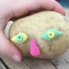
How can we explore materials and marks?  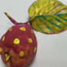 |  |  |  |  |  | How can we use our bodies to make art?  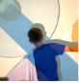 |  |  |  |  |  |  |  |  |  |  |  | How can we build worlds and/or How can we use our imaginations?  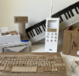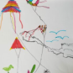
Scheme – Music - Charanga
Nursery to sing songs and nursery rhymes from the Charanga song library each week.
Put percussion instruments in CP areas.
Me! | My Stories |  |  |  |  | Everyone! |  |  |  |  | Our World |  |  |  |  |  |  | Big Bear Funk |  |  |  |  | Reflect, Rewind and Replay

