Maths Calculation Guidance

Lindridge St Lawrence CE (VA) Primary School


‘Discovering life in all its fullness.’
Hesed Hamdah Honesty Horizons

Produced by White Rose Maths
Edited for Lindridge St Lawrence CE (VA) Primary by Mark Pickford September 2025


Calculation: Addition
Key language: sum, total, parts and wholes, plus, add, altogether, more, ‘is equal to’ ‘is the same as’.

Concrete | Pictorial | Abstract
Combining two parts to make a whole (use other resources too e.g. eggs, shells, teddy bears, cars).  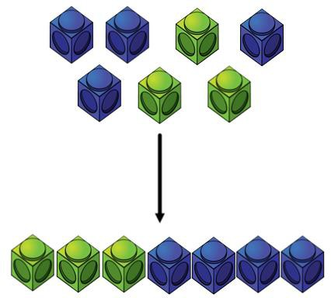 | Children to represent the cubes using dots or crosses. They could put each part on a part whole model too.  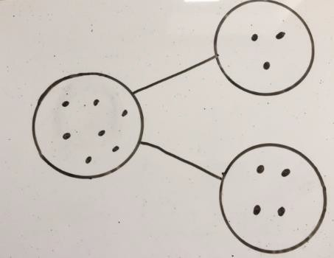 | 4 + 3 = 7  Four is a part, 3 is a part and the whole is seven.  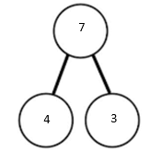
Counting on using number lines using cubes or Numicon.  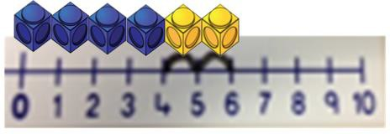  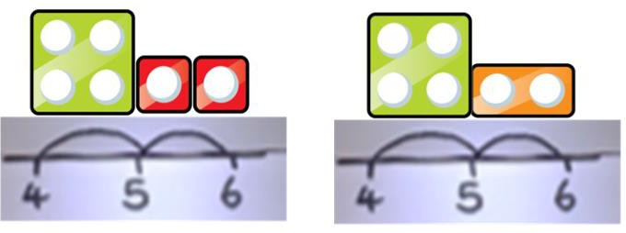 | A bar model which encourages the children to count on, rather than count all.  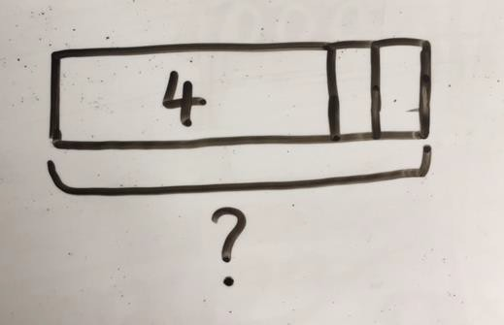 | The abstract number line: What is 2 more than 4? What is the sum of 2 and 4? What is the total of 4 and 2? 4 + 2  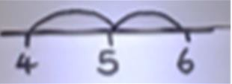

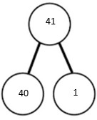
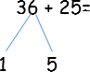
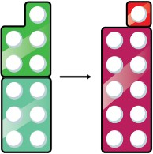
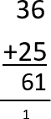
Regrouping to make 10; using ten frames and counters/cubes or using Numicon.  6 + 5  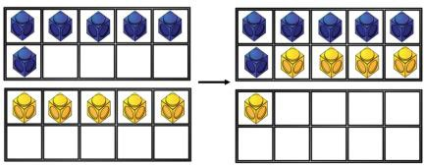 | Children to draw the ten frame and counters/cubes.  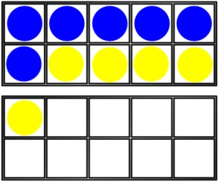 | Children to develop an understanding of equality e.g.  6 + □ = 11  6 + 5 = 5 + □  6 + 5 = □ + 4
TO + O using base 10. Continue to develop understanding of partitioning and place value.  41 + 8  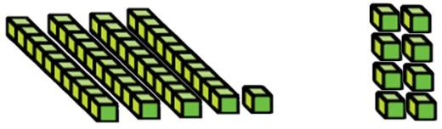 | Children to represent the base 10 e.g. lines for tens and dot/crosses for ones.  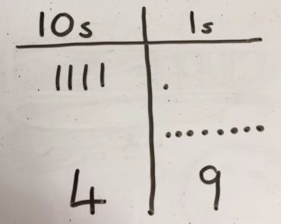 | 41 + 8  1 + 8 = 9  40 + 9 = 49  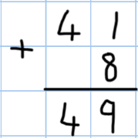
TO + TO using base 10. Continue to develop understanding of partitioning and place value. 36 + 25 | Chidlren to represent the base 10 in a place value chart.  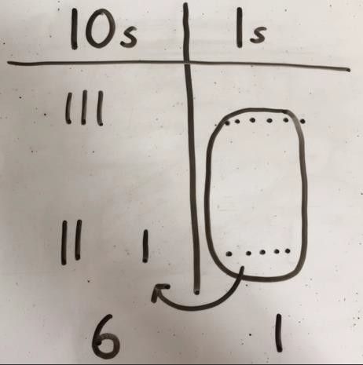 | Looking for ways to make 10.  30 + 20 = 50  5 + 5 = 10  50 + 10 + 1 = 61  Formal method:

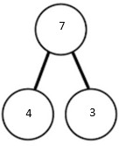



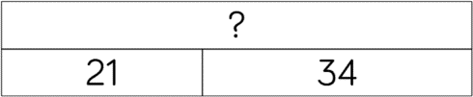
Use of place value counters to add HTO + TO, HTO + HTO etc. When there are 10 ones in the 1s column- we exchange for 1 ten, when there are 10 tens in the 10s column- we exchange for 1 hundred.  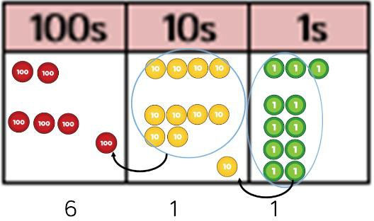 |  |  |  | Children to represent the counters in a place value chart, circling when they make an exchange.  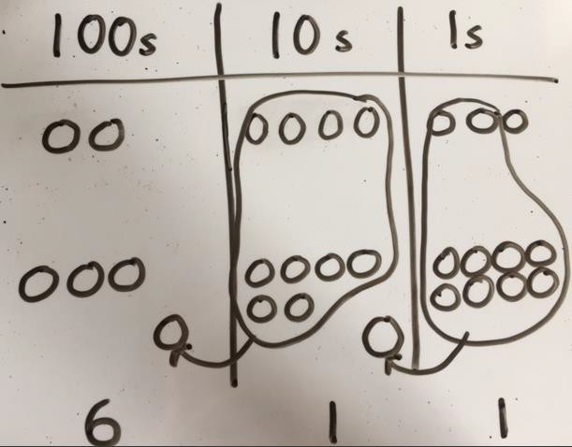 |  | 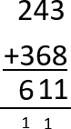
Conceptual variation; different ways to ask children to solve 21 + 34
 | ? |  | Word problems:  In year 3, there are 21 children and in year 4, there are 34 children.  How many children in total? |  | 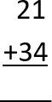  21 + 34 =  = 21 + 34  Calculate the sum of twenty-one and thirty-four. | 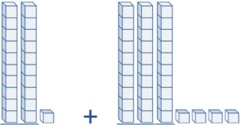
21 |  | 34 | 21 + 34 = 55. Prove it
 |  |  |  |  |  | Missing digit problems:
 |  |  |  |  |  | 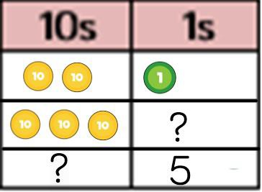


Calculation: Subtraction
Key language: take away, less than, the difference, subtract, minus, fewer, decrease.

Concrete | Pictorial | Abstract
Physically taking away and removing objects from a whole (ten frames, Numicon, cubes and other items such as beanbags could be used).  4 – 3 = 1  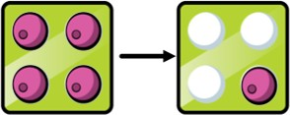   | Children to draw the concrete resources they are using and cross out the correct amount. The bar model can also be used.  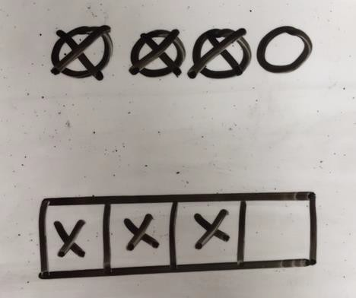 | 4- 3 =  = 4 – 3  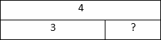  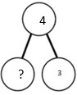
Counting back (using number lines or number tracks) children start with 6 and count back 2.  6 – 2 = 4  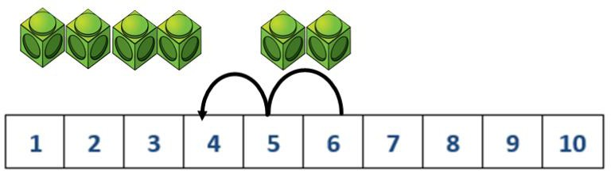 | Children to represent what they see pictorially e.g.  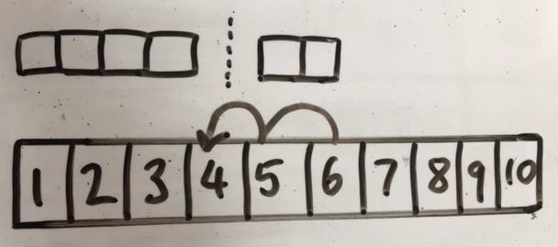 | Children to represent the calculation on a number line or number track and show their jumps. Encourage children to use an empty number line  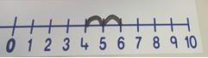  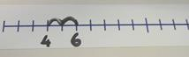

Finding the difference (using cubes, Numicon or Cuisenaire rods, other objects can also be used).  Calculate the difference between 8 and 5.  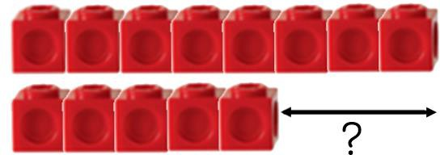 | Children to draw the cubes/other concrete objects which they have used or use the bar model to illustrate what they need to calculate.  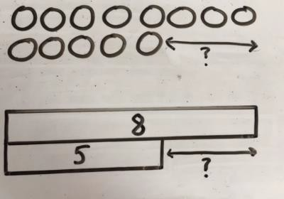 | Find the difference between 8 and 5. 8 – 5, the difference is  Children to explore why  9 - 6 = 8 – 5 = 7 – 4 have the same difference.
Making 10 using ten frames. 14 – 5  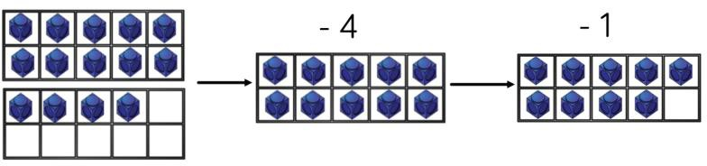 | Children to present the ten frame pictorially and discuss what they did to make 10.  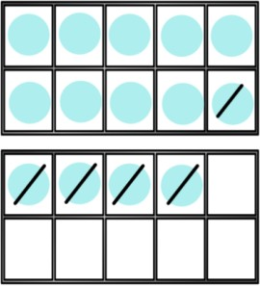 | Children to show how they can make 10 by partitioning the subtrahend.  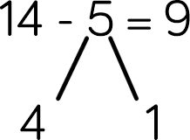  14 – 4 = 10  10 – 1 = 9
Column method using base 10. 48-7  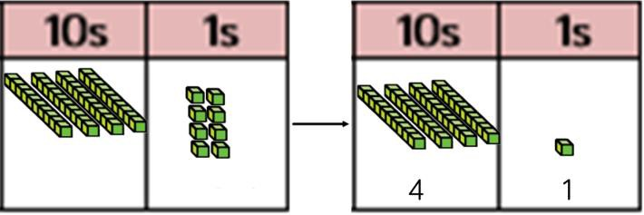 | Children to represent the base 10 pictorially.  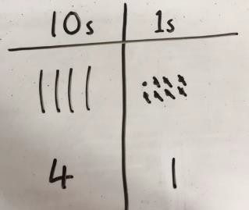 | Column method or children could count back 7.  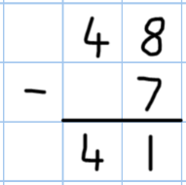

Column method using base 10 and having to exchange. 41 – 26  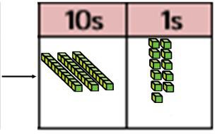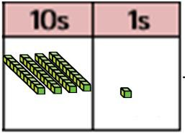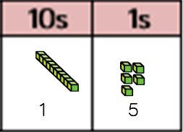 |  | Represent the base 10 pictorially, remembering to show the exchange.  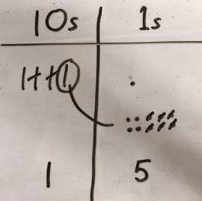 |  |  |  | Formal column method. Children must understand that when they have exchanged the 10 they still have 41 because 41 = 30 + 11.  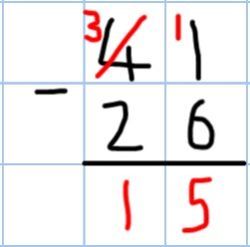
Column method using place value counters. 234 – 88 |  | Represent the place value counters pictorially; remembering to show what has been exchanged.  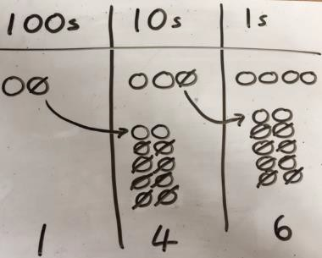 |  |  |  | Formal colum method. Children must understand what has happened when they have crossed out digits.  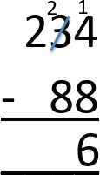
Conceptual variation; different ways to ask children to solve 391 - 186
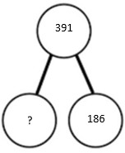  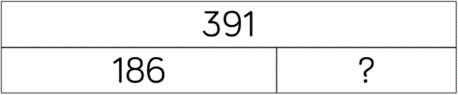 | Raj spent £391, Timmy spent £186. How much more did Raj spend?  Calculate the difference between 391 and 186. |  |  |  | = 391 – 186 | Missing digit calculations  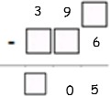
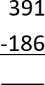
What is 186 less than 391?

Calculation: Multiplication
Key language: double, times, multiplied by, the product of, groups of, lots of, equal groups.

Concrete | Pictorial | Abstract
Repeated grouping/repeated addition 3 × 4  4 + 4 + 4  There are 3 equal groups, with 4 in each group.  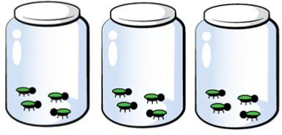  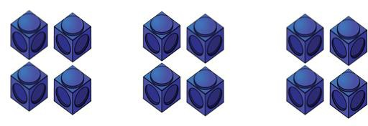 | Children to represent the practical resources in a picture and use a bar model.  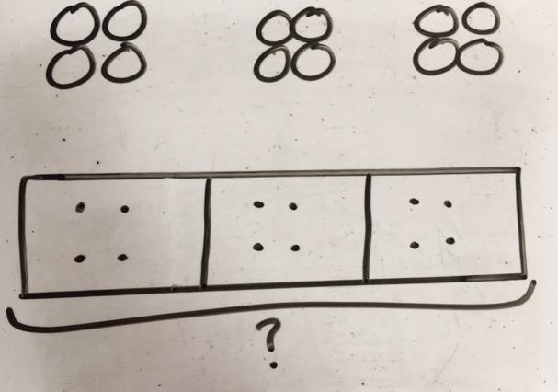 | 3 × 4 = 12  4 + 4 + 4 = 12
Number lines to show repeated groups- 3 × 4  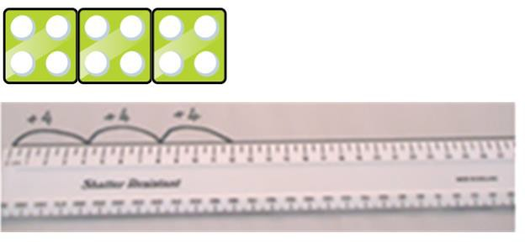  Cuisenaire rods can be used too. | Represent this pictorially alongside a number line e.g.:  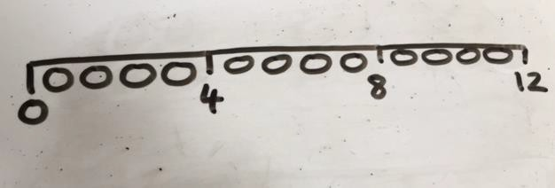 | Abstract number line showing three jumps of four.  3 × 4 = 12  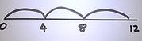

Use arrays to illustrate commutativity counters and other objects can also be used.  2 × 5 = 5 × 2  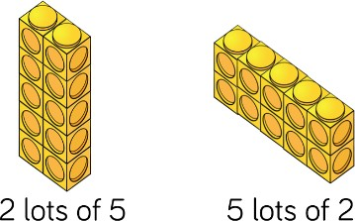 | Children to represent the arrays pictorially.  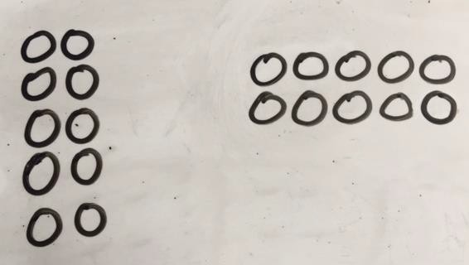 | Children to be able to use an array to write a range of calculations e.g.  10 = 2 × 5  5 × 2 = 10  2 + 2 + 2 + 2 + 2 = 10  10 = 5 + 5
Partition to multiply using Numicon, base 10 or Cuisenaire rods.  4 × 15  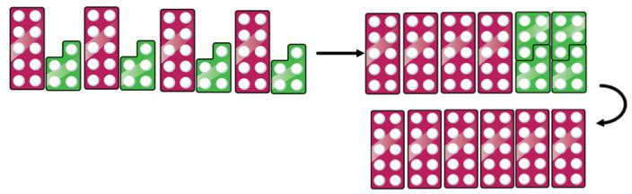 | Children to represent the concrete manipulatives pictorially.  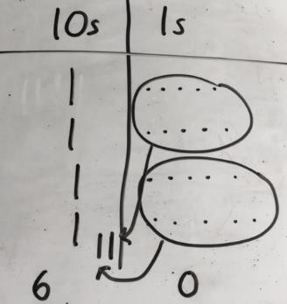 | Children to be encouraged to show the steps they have taken.  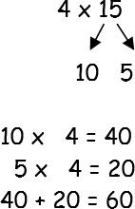  A number line can also be used  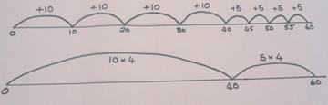
Formal column method with place value counters (base 10 can also be used.) 3 × 23  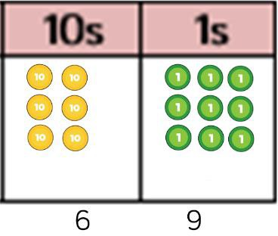 | Children to represent the counters pictorially.  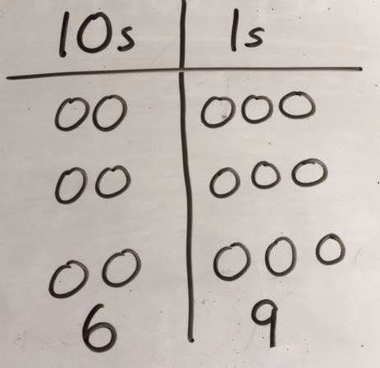 | Children to record what it is they are doing to show understanding.  3 × 23 3 × 20 = 60  3 × 3 = 9  20 3 60 + 9 = 69  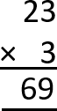

Formal column method with place value counters. 6 x 23  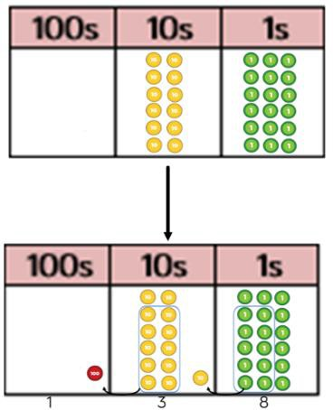 |  | Children to represent the counters/base 10, pictorially  e.g. the image below.  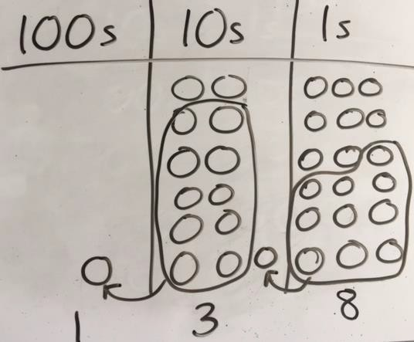 |  | Formal written method  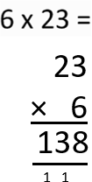
When children start to multiply 3d × 3d and 4d × 2d etc., they should be confident with the abstract:  To get 744 children have solved 6 × 124.  To get 2480 they have solved 20 × 124. |  |  |  | 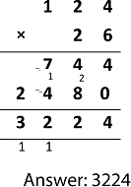
Conceptual variation; different ways to ask children to solve 6 × 23
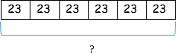 | Mai had to swim 23 lengths, 6 times a week.  How many lengths did she swim in one week?  With the counters, prove that 6 x 23  = 138 |  | Find the product of 6 and 23 6 × 23 =  = 6 × 23  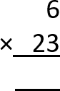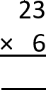 | What is the calculation? What is the product?  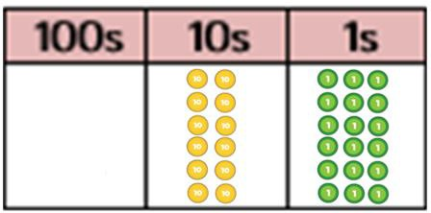

Key language: share, group, divide, divided by, half.
Calculation : Division

Concrete | Pictorial | Abstract
Sharing using a range of objects. 6 ÷ 2  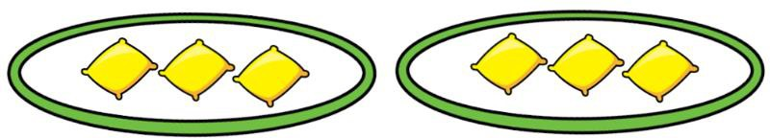  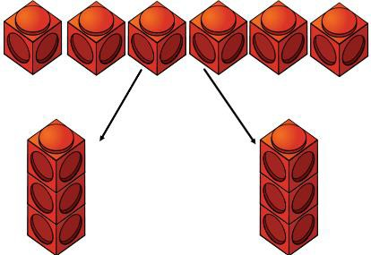 | Represent the sharing pictorially.  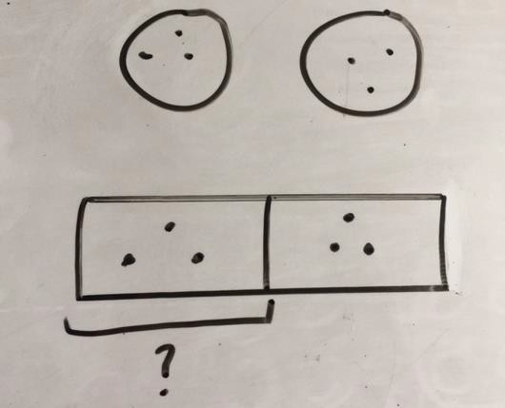 | 6 ÷ 2 = 3  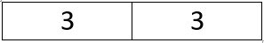  Children should also be encouraged to use their 2 times tables facts.
Repeated subtraction using Cuisenaire rods above a ruler. 6 ÷ 2  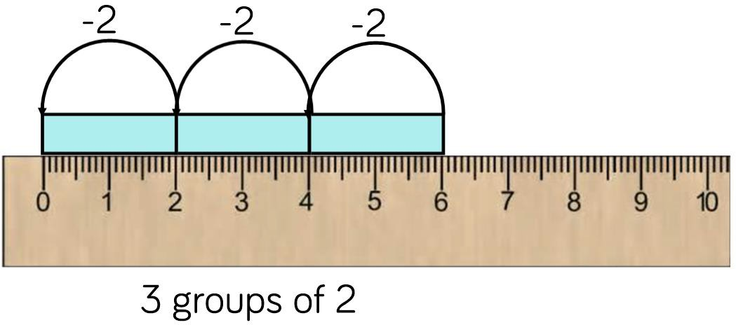 | Children to represent repeated subtraction pictorially.  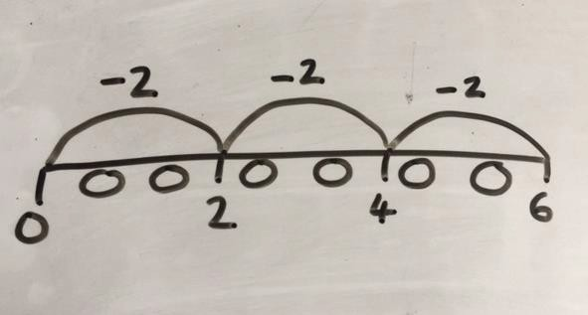 | Abstract number line to represent the equal groups that have been subtracted.  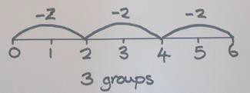

2d ÷ 1d with remainders using lollipop sticks. Cuisenaire rods, above a ruler can also be used.  13 ÷ 4  Use of lollipop sticks to form wholes- squares are made because we are dividing by 4.  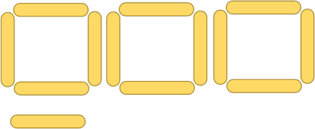  There are 3 whole squares, with 1 left over. | Children to represent the lollipop sticks pictorially.  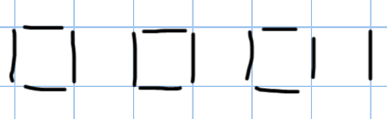  There are 3 whole squares, with 1 left over. | 13 ÷ 4 – 3 remainder 1  Children should be encouraged to use their times table facts; they could also represent repeated addition on a number line.  ‘3 groups of 4, with 1 left over’  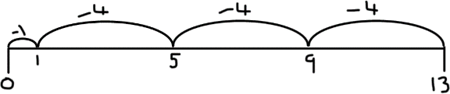
Sharing using place value counters. 42 ÷ 3 = 14  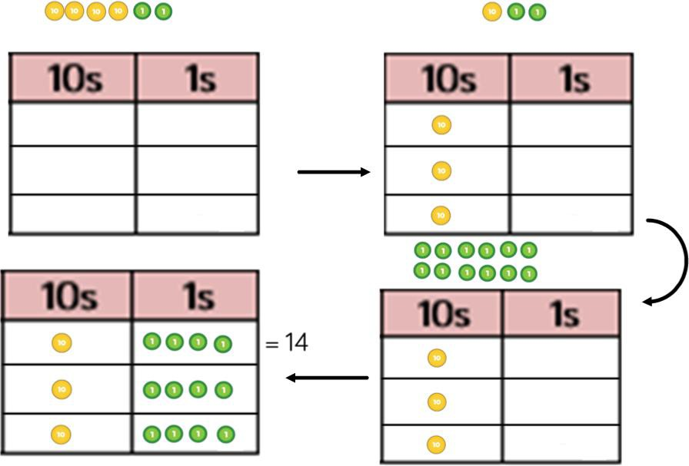 | Children to represent the place value counters pictorially.  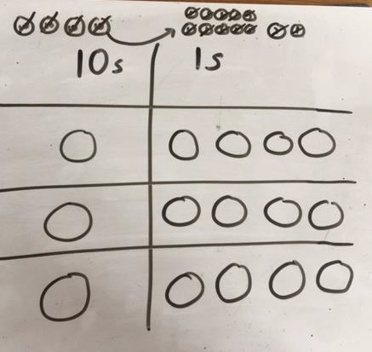 | Children to be able to make sense of the place value counters and write calculations to show the process.  42 ÷ 3  42 = 30 + 12  30 ÷ 3 = 10  12 ÷ 3 = 4  10 + 4 = 14

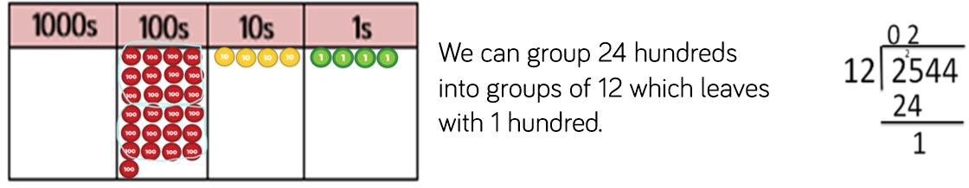
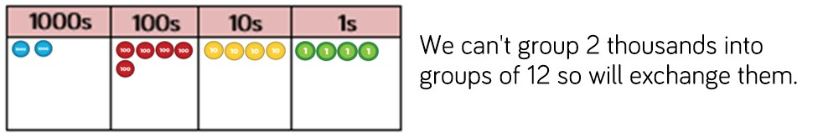
Short division using place value counters to group. 615 ÷ 5  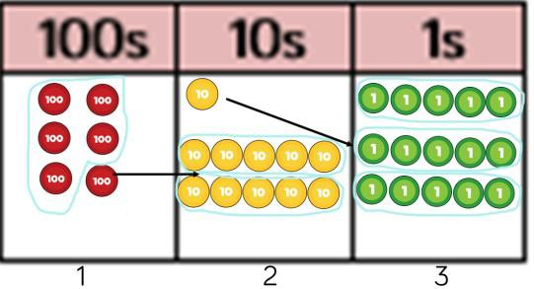  - Make 615 with place value counters.  - How many groups of 5 hundreds can you make with 6 hundred counters?  - Exchange 1 hundred for 10 tens.  - How many groups of 5 tens can you make with 11 ten counters?  - Exchange 1 ten for 10 ones.  - How many groups of 5 ones can you make with 15 ones? | Represent the place value counters pictorially.  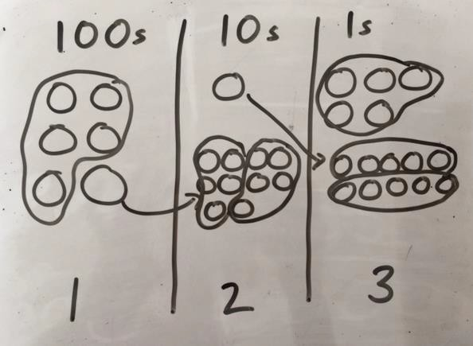 | Children to the calculation using the short division scaffold.  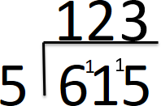
Long division using place value counters 2544 ÷ 12

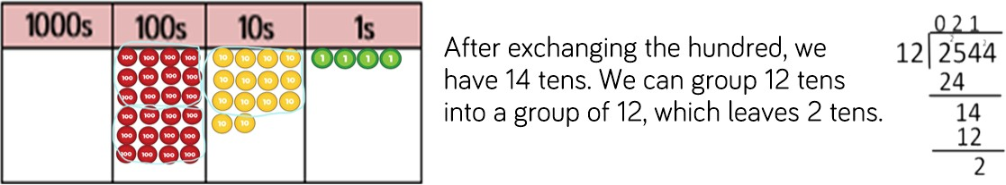

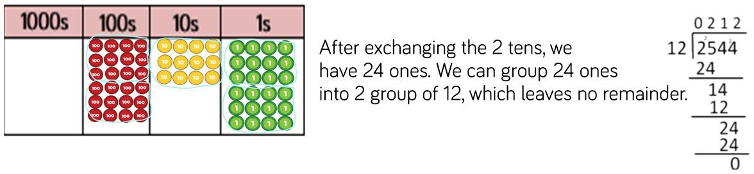
Conceptual variation; different ways to ask children to solve 615 ÷ 5
Using the part whole model below, how can you divide 615 by 5 without using short division?  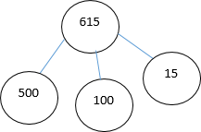 | I have £615 and share it equally between 5 bank accounts. How much will be in each account?  615 pupils need to be put into 5 groups. How many will be in each group? | 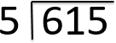  615 ÷ 5 =  = 615 ÷ 5 | What is the calculation? What is the answer?  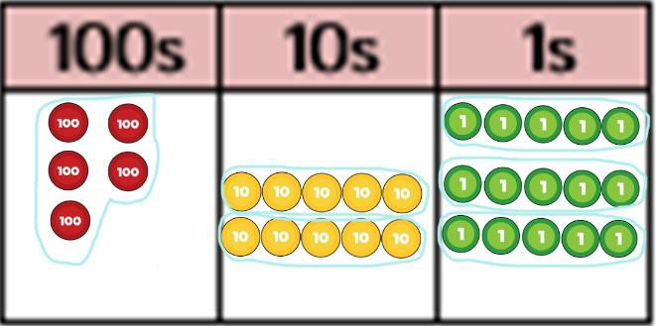


Calculation: Guidance

 | EYFS/Year 1 | Year 2 | Year 3 | Year 4 | Year 5 | Year 6
Addition | Combining two parts to make a whole: part whole model. | Adding three single digits. | Column method- regrouping. | Column method- regrouping. | Column method- regrouping. | Column method- regrouping.
Addition | Starting at the bigger number and counting on- using cubes.  Regrouping to make 10 using ten frame. | Use of base 10 to combine two numbers. | Using place value  Counters (up to 3 digits). | (up to 4 digits) | Use of place value counters for adding decimals. | Abstract methods.  Place value counters to be used for adding decimal numbers.
Subtraction | Taking away ones | Counting back | Column method with regrouping.  (up to 3 digits using place value counters) | Column method with regrouping. | Column method with regrouping.  Abstract for whole numbers.  Start with place value counters for decimals- with the same amount of decimal places. | Column method with regrouping.
Subtraction | Counting back | Find the difference
Subtraction |  |  |  | (up to 4 digits) |  | Abstract methods.
Subtraction | Find the difference | Part whole model
Subtraction | Part whole model  Make 10 using the ten frame | Make 10  Use of base 10 |  |  |  | Place value counters for decimals- with different amounts of decimal places.

Multiplication | Recognising and making equal groups.  Doubling  Counting in multiples Use cubes, Numicon and other objects in the classroom | Arrays- showing commutative multiplication | Arrays  2d × 1d using base 10 | Column multiplication- introduced with place value counters.  (2 and 3 digit multiplied by 1 digit) | Column multiplication  Abstract only but might need a repeat of year 4 first(up to 4 digit numbers multiplied by 1 or 2 digits) | Column multiplication  Abstract methods (multi-digit up to 4 digits by a 2 digit number)
Division | Sharing objects into groups  Division as grouping e.g. I have 12 sweets and put them in groups of 3, how many groups?  Use cubes and draw round 3 cubes at a time. | Division as grouping  Division within arrays- linking to multiplication  Repeated subtraction | Division with a remainder-using lollipop sticks, times tables facts and repeated subtraction.  2d divided by 1d using base 10 or place value counters | Division with a remainder  Short division (up to 3 digits by 1 digit- concrete and pictorial) | Short division  (up to 4 digits by a 1 digit number including remainders) | Short division  Long division with place value counters (up to 4 digits by a 2 digit number)  Children should exchange into the tenths and hundredths column too

