Lindridge St Lawrence CE Primary School
Science Progression Grid
The progression grid outlines the specific knowledge and skills which pupils are expected to learn in each phase, over a two year cycle, along with the specific vocabulary which supports this understanding. Each unit of work is gathered under the appropriate scientific discipline, and where possible progression grids are organised to support the order of the learning journey across school. Also below is a progression map which highlights the teaching sequence over the two year cycle. Teachers may revisit parts of units or specific information from previous units with pupils to ensure their full understanding before embarking on the next phase of learning due to the two cycle, to ensure pupils have learnt and retained the knowledge needed.
Scientific Enquiry – The skills every pupil needs to ensure they can be a scientist
Skills | At EYFS:  Children know about similarities and differences in relation to places, objects, materials and living things  Children talk about the features of their own immediate environment and how environments might vary from one another  Children describe shapes, spaces, and measures | At Years 1/2  E1: ask simple questions and recognise that they can be answered in different ways  E2: observe closely, using simple equipment  E3: perform simple tests E4: identify and classify E5: use their observations and ideas to suggest answers to questions  E6: gather and record data to help in answering questions | At Year 3/4  E1: ask relevant questions and use different types of scientific enquiries to answer them E2: set up simple practical enquiries, comparative and fair tests  E3: make systematic and careful observations and, where appropriate, take accurate measurements using standard units, using a range of equipment, including thermometers and data loggers  E4: gather, record, classify and present data in a variety of ways to help in answering questions  E5: record findings using simple scientific language, drawings, labelled diagrams, keys, bar charts, and tables  E6: report on findings from enquiries, including oral and written explanations, displays or presentations of results and conclusions  E7: use results to draw simple conclusions, make predictions for new values, suggest improvements and raise further questions  E8: identify differences, similarities or changes related to simple scientific ideas and processes  E9: use straightforward scientific evidence to answer questions or to support their findings. | At Year 5/6  E1: plan different types of scientific enquiries to answer questions, including recognising and controlling variables where necessary E2: take measurements, using a range of scientific equipment, with increasing accuracy and precision, taking repeat readings when appropriate  E3: record data and results of increasing complexity using scientific diagrams and labels, classification keys, tables, scatter graphs, bar and line graphs  E4: using test results to make predictions to set up further comparative and fair tests  E5: report and present findings from enquiries, including conclusions, causal relationships and explanations of and degree of trust in results, in oral and written forms such as displays and other presentations  E6: identify scientific evidence that has been used to support or refute ideas or arguments
Being a Scientist – Exemplifying scientific behaviours which ensure pupils know more and remember more
Skills | At EYFS:  Children make observations of animals and plants and explain why some things occur, and talk about changes  Children use what they have learnt about media and materials in original ways, thinking about uses and purposes | At Key Stage One:  B1: Enable pupils to experience and observe phenomena, looking more closely at the natural and humanly-constructed world around them.  B2: They should be encouraged to be curious and ask questions about what they notice.  B3: They should be helped to develop their understanding of scientific ideas by using different types of scientific enquiry to answer their own questions, including observing changes over a period of time, noticing patterns, grouping and classifying things, carrying out simple comparative tests, and finding things out using secondary sources of information.  B4: They should begin to use simple scientific language to talk about what they have found out and communicate their ideas to a range of audiences in a variety of ways. | At Lower Key Stage Two:  B1: Pupils in years 3 and 4 should be given a range of scientific experiences to enable them to raise their own questions about the world around them.  B2: They should start to make their own decisions about the most appropriate type of scientific enquiry they might use to answer questions; recognise when a simple fair test is necessary and help to decide how to set it up; talk about criteria for grouping, sorting and classifying; and use simple keys.  B3: They should begin to look for naturally occurring patterns and relationships and decide what data to collect to identify them  B4: They should help to make decisions about what observations to make, how long to make  them for and the type of simple equipment that might be used.  B5: They should learn how to use new equipment, such as data loggers, appropriately.  B6: They should collect data from their own observations and measurements, using notes, simple tables and standard units, and help to make decisions about how to record and analyse this data.  B7: With help, pupils should look for changes, patterns, similarities and differences in their data in order to draw simple conclusions and answer questions.  B8: With support, they should identify new questions arising from the data, making predictions for new values within or beyond the data they have collected and finding ways of improving what they have already done.  B9: They should also recognise when and how secondary sources might help them to answer questions that cannot be answered through practical investigations.  B10: Pupils should use relevant scientific language to discuss their ideas and communicate their findings in ways that are appropriate for different audiences. | At Upper Key Stage Two:  B1: Pupils in years 5 and 6 should use their science experiences to: explore ideas and raise different kinds of questions; select and plan the most appropriate type of scientific enquiry to use to answer scientific questions; recognise when and how to set up comparative and fair tests and explain which variables need to be controlled and why.  B2: They should use and develop keys and other information records to identify, classify and describe living things and materials, and identify patterns that might be found in the natural environment.  B3: They should make their own decisions about what observations to make, what measurements to use and how long to make them for, and whether to repeat them; choose the most  appropriate equipment to make measurements and explain how to use it accurately.  B4: They should decide how to record data from a choice of familiar approaches; look for different causal relationships in their data and identify evidence that refutes or supports their ideas.  B5: They should use their results to identify when further tests and observations might be needed; recognise which secondary sources will be most useful to research their ideas and begin to separate opinion from fact.  B6: They should use relevant scientific language and illustrations to discuss, communicate and justify their scientific ideas and should talk about how scientific ideas have developed over time.

Cycle of Learning

Year A – Science Units
 |  | Autumn 1 | Autumn 2 | Spring 1 | Spring 2 | Summer 1 | Summer 2
Year 1/2 |  | Materials  - Properties of materials  - Identify materials  - Investigation the absorbency  - Identify appropriate materials for a specific purpose | Seasonal Changes  - Observe changes across the four seasons.  - Observe and describe weather associated with the seasons.  - Observe and describe how day length changes.  Make tables and charts about the weather and make displays of what happens in the world around them including day length as the seasons change | Animals including humans -skeleton and Body Parts  - Identify, name and label parts of the body  - Say which part of the body links with each sense  - Use your senses to compare different textures, sounds and smells  - Describe the importance for humans of eating different types of food | Plants  - Can I observe, sort and record plants in my local environment.  - Life cycle of a plant  - Observe and describe how seeds and bulbs grow in to mature plants.  Find out and describe how plants need water, light and a suitable temperature to grow and stay healthy (observe changes over time and set up a comparative test) | Living things and their habitats  - Compare things that are living, dead and never been alive.  - Mapping habitats and explain what’s in them  - Name key plants and animals from a variety of habitats | - Jigsaw PSHE RSE units
Y3/4 |  | Rocks  -sorting natural and human made rocks – intro  -classifying rock types  -local walk to spot rocks (natural and human made)  Focus in on gravestones in the graveyard. Look at the different ages. How have they changed over time? Why?  -Understanding rock formation (sedimentary, igneous, metamorphic). Use the Starburst lesson to demo rock formation and the rock cycle.  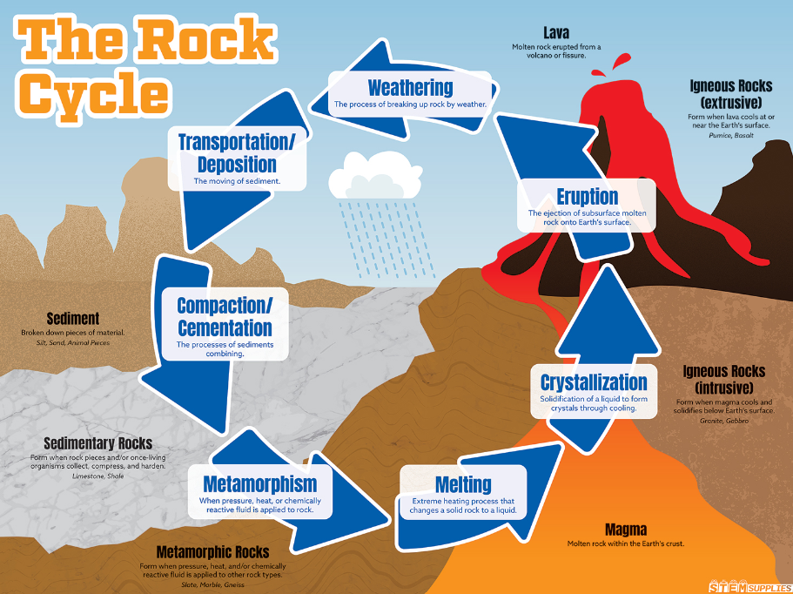  -test permeable/impermeable by weighing rocks after they have been immersed in water eg brick/granite/chalk/limestone  -mystery fossils session (4 different types). What rock is it, what fossil is it, how do you know, how can you test to be sure?  -soil – test soakers/drainers then make your own effective compost. | Electricity  -identify electrical vs non-electrical items  -Build a simple circuit (battery, wires, bulb)  -Recognise complete and incomplete circuits  -Troubleshoot why a circuit doesn’t work  -Test materials (conductors vs insulators)  -Add and use switches in circuits  -Investigate effect of more bulbs/batteries  -Draw simple circuit diagrams (symbols for Y4)  -Identify electricity in everyday objects  -Design and make a simple electrical product (e.g. torch/card) | Animals including humans – digestion and teeth  -Identify types of teeth (incisors, canines, molars)  -Understand functions of teeth (cutting, tearing, grinding)  -Learn about tooth care and hygiene  -Identify parts of the human digestive system  -Sequence the digestive process (mouth → stomach → intestines)  -Understand the role of saliva and chewing  -Explore how nutrients are absorbed  -Investigate effects of diet on teeth (sugar, healthy eating) 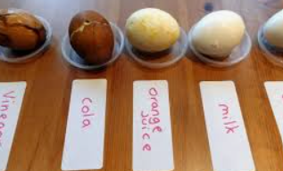  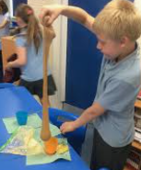 | States of matter  -Identify solids, liquids, and gases  - Group materials based on their state  -Compare properties (shape, volume, movement)  - Explore how materials change state (heating/cooling)  -Observe melting and freezing  -Understand evaporation and condensation (water cycle link)  -Measure or observe temperature changes  -Explain simple changes using scientific vocabulary | Living things and their habitats - classification  -Identify living and non-living things  -Group animals based on characteristics (basic classification)  -Sort living things into groups (e.g. mammals, birds, fish, insects)  -Understand what a habitat is  -Match animals to their habitats  -Explore how habitats provide what animals need (food, shelter, water)  -Identify simple food chains  -Describe how animals depend on each other  -Recognise how environments can change  -Understand how changes affect living things | Jigsaw PSHE RSE units
 | Y5/6 | Materials Properties and changing states  - Compare and group together everyday materials on the basis of their properties, including their hardness, solubility, transparency, conductivity (electrical and thermal), and response to magnets  - Know that some materials will dissolve in liquid to form a solution, and describe how to recover a substance from a solution  - Use knowledge of solids, liquids and gases to decide how mixtures might be separated, including through filtering, sieving and evaporating  - Give reasons, based on evidence from comparative and fair tests, for the particular uses of everyday materials, including metals, wood and plastic  - Demonstrate that dissolving, mixing and changes of state are reversible changes  - Explain that some changes result in the formation of new materials, and that this kind of change is not usually reversible, including changes associated with burning and the action of acid on bicarbonate of soda. | Materials Properties and changing states  - Carrying out tests to answer questions, for example, ‘Which materials would be the most effective for making a warm jacket, for wrapping ice cream to stop it melting, or for making blackout curtains?’  - Compare materials in order to make a switch in a circuit  - Observe and compare the changes that take place, for example, when burning different materials or baking bread or cakes.  - Research and discuss how chemical changes have an impact on our lives, for example, cooking, and discuss the creative use of new materials such as polymers, super sticky and super-thin materials. | Animals including humans – blood, circulation and respiration  -Identify main parts of the circulatory system (heart, blood vessels, blood)  Could use pig hearts to dissect.  -Understand the function of the heart (pumping blood)  -Describe how blood transports oxygen, nutrients, and waste  -Identify components of blood (red cells, white cells, platelets, plasma)  -Understand lungs and the process of respiration  -Explain how oxygen enters the blood and carbon dioxide leaves  -Compare pulse rates before and after exercise (practical investigation)  -Recognise the impact of exercise on heart and breathing  -Know the importance of a healthy lifestyle for heart health  -Identify risks to the body (smoking, poor diet, lack of exercise) | Earth and Space  -Describe the Sun, Earth, and Moon as spherical bodies  -Understand the Sun as the centre of the solar system  -Identify planets and their order from the Sun  -Explain how the Earth rotates (day and night)  -Understand how the Earth orbits the Sun (year)  -Explain how the Moon orbits the Earth  -Describe phases of the Moon (basic)  -Use models to show movement of Earth and Moon  -Explain why shadows change size and position  -Explore how ideas about space have changed over time  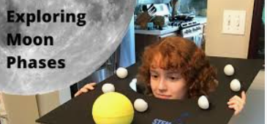 | Living things and their habitats – classification and variation  -Identify ways of classifying living things (plants, animals, microorganisms)  -Group organisms based on similarities and differences  -Use classification keys to identify organisms  -Create simple branching databases/keys  -Understand characteristics of different groups (e.g. vertebrates vs invertebrates)  -Describe how living things vary within a species  -Recognise inherited and environmental variation  -Explore examples of adaptation  -Understand that variation helps survival  -Compare different species and explain differences | Puberty and Body Changes (RSE for Y5s only)  Conception and child birth (RSE for Y6s only)

Year B – Science Units
 | Autumn 1 | Autumn 2 | Spring 1 | Spring 2 | Summer 1 | Summer 2
Year 1/2 | Materials  - Properties of materials  - Changing materials – squashing, bending, twisting, stretching  - Record changes to materials over time  Compare the use of everyday materials found in and around the school with materials found in other places | Animals including humans  - Describe the importance for exercise and hygiene for humans  - Life cycle – notice that animals including humans have babies (compare a reptile, a mammal and a bird)  Observation over time of an amphibian (frogspawn) | Plants  - Identify and name a variety of common wild and garden plants including deciduous and evergreen trees.  Identify and describe the basic structure of a variety of common flowering plants including trees (compare and contrast plants, keep records of how plants have changed over time) | Animals including humans  - Identify and name a variety of common animals including fish, amphibians, reptiles, birds and mammals.  - Identify and name animals who are omnivores, herbivores and carnivores.  - Describe and compare the structure of a variety of common animals (exoskeleton / endoskeleton) | Living things and their habitats  - Food chains  Compare things that are living, dead and never been alive – using exploration questions such as is a flame alive, is a deciduous tree dead in winter?
Y3/4 | Light and Shadows  -light sources intro  -investigate/test materials for transparent, translucent and opaque  -protecting eyes from the sun (test wide brimmed hats and different sunglasses to find the most effective ways to protect our eyes.)  -testing materials to find out the best material for a high vis jacket.  -shadows experiment (can they make the shadows bigger or smaller and can they say why?) | Sound  -Identify how sounds are made (vibrations)  -Explore how vibrations travel through materials  -Recognise that sound travels through solids, liquids, and gases  -Investigate how volume is made louder or quieter  -Investigate how pitch is higher or lower  -Explore how distance affects how well we hear a sound  -Identify parts of the ear (basic understanding)  -Match everyday objects to the sounds they make  -Carry out simple sound investigations (e.g. string telephones) | Animals including humans – skeletons and muscles  -look at xrays of animals to sort verterbrates/invertebrates  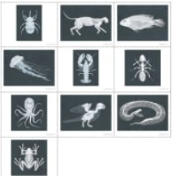  -herbivores, carnivores, ominvores  What links are there between where an animal’s eyes are and what it eats? Sort into herbivores/not herbivores. Then look closer after information video (using last year’s Y2s as experts) to sort them into carnivores or omnivores.  -our skeleton – bucket school, make giant skeletons and then rate them according to accuracy  -muscles – exercise then make a muscle model  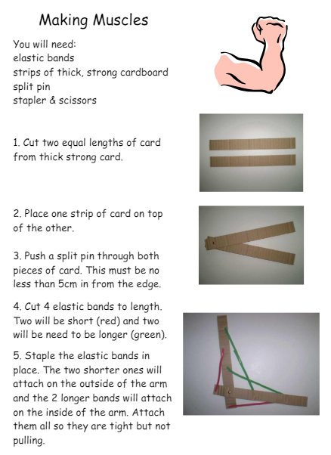  -diet and nutrition  How can we eat to stay healthy?  Pack a picnic that gives a human everything they need to be healthy.  Match the diet to the living thing. | Forces and Magnets  -forces investigation  Investigate which shoe has the best friction on a slippy surface (test a stiletto, trainer, welly, walking boot, flip flop, slipper)  -investigate (using newton meters) how much force does it take to pull different objects?  -magnets – investigate if magnetism works through different materials. Test in water, through cardboard, metal, wood, a brick wall.  -apply their knowledge of magnets by creating a magnetic game. (eg fishing game) | Plants  -when labelling the plant parts, dissect a plant, label it and laminate the dissected/labelled plant to display in the windows. Include ‘think deeper’ questions.  -life cycles of flowering plants. Divide class into 5 groups. They will have a different plant each to order photographs and then explain each stage of the life cycle. They will present what they have learnt to the rest of the class.  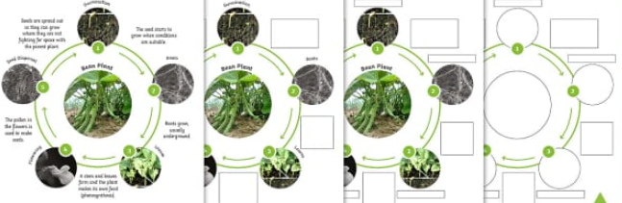  -transportation investigation  Experiment using different coloured water and a split stem carnation.  Experiment by putting celery into coloured water and predicting the outcome.  -Investigate roots of different plants. | Plants  -Seed dispersal and pollination  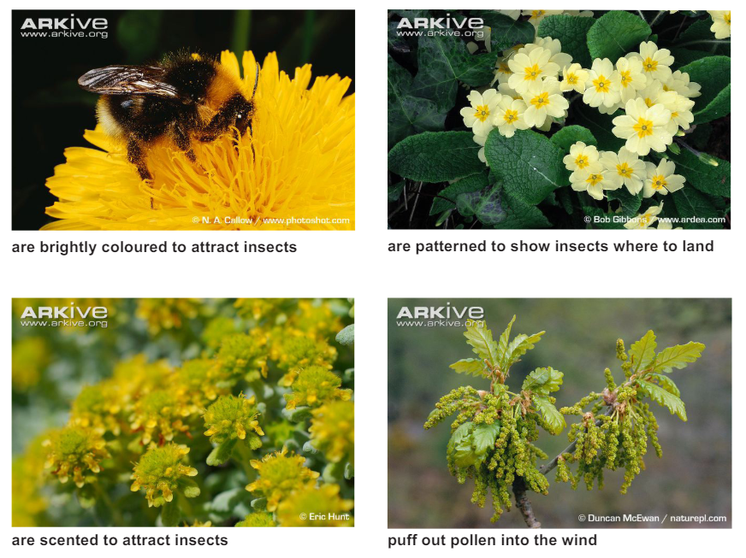  Go on a nature walk and find 8 different flowering plants. Use the checklist to find out how the plant is pollinating (insects-bright flowers/patterned flowers/scented or wind – has clusters of visible pollen that is puffed out.
Y5/6 | Light  -Understand that light travels in straight lines  -Recognise that light is needed to see objects  -Explain how light reflects off surfaces  -Identify reflective materials  -Understand how shadows are formed  -Investigate how shadow size changes (distance/light source)  -Explain that shadows are the same shape as the object  -Use diagrams to show how light travels and reflects  -Explore how periscopes or mirrors work  -Understand how we protect our eyes from light | Evolution and inheritance  -Recognise that living things have changed over time  -Understand that fossils provide evidence of the past  -Identify how characteristics are inherited from parents  -Explore variation within a species  -Distinguish between inherited and environmental traits  -Understand the basics of adaptation  -Explain how adaptations help survival  -Recognise that environments can drive evolutionary change  -Explore examples of animal and plant adaptations  -Understand that evolution occurs over long periods of time | Electricity  -Recognise common electrical symbols and draw circuit diagrams  -Build and represent more complex circuits using symbols  -Understand how voltage affects components  -Investigate how brightness/volume changes with components  -Use recognised symbols to plan circuits before building  -Compare series circuits (no parallel required at KS2)  -Identify and correct faults in circuits (systematic testing)  -Explain how components function within a circuit  -Apply knowledge to design and build a purposeful circuit  -Record and interpret results from electrical investigations | Forces and magnets  -Identify different types of forces (pushes and pulls)  -Understand that forces can make objects move, stop, or change direction  -Explore gravity as a force pulling objects towards the Earth  -Investigate friction and its effect on movement  -Explore air resistance and water resistance  -Recognise that some mechanisms allow a smaller force to have a greater effect (e.g. levers, pulleys, gears)  -Carry out simple force investigations (e.g. surfaces and friction)  -Measure forces using simple equipment (e.g. Newton meters – basic use)  -Record and compare results from investigations --Explain findings using simple scientific language | Plants – Fertilisation/Pollination  -Identify parts of a flower (stamen, pistil/carpel, pollen, ovule)  -Understand what pollination is (transfer of pollen)  -Identify different methods of pollination (wind, insects, animals)  -Explore the role of bees and insects in pollination  -Understand what fertilisation is (joining of pollen and ovule)  -Sequence the process: pollination → fertilisation → seed formation  -Recognise how seeds and fruits develop  -Compare different methods of seed dispersal  -Carry out simple investigations (e.g. modelling pollination)  -Explain processes using correct scientific vocabulary | Puberty and Body Changes (RSE for Y5s only)  Conception and child birth (RSE for Y6s only)

Biology – Animals including humans
 | Years 1/2 | Year 3/4 | Year 5/6
k | - identify and name a variety of common animals including fish, amphibians, reptiles, birds and mammals  - identify and name a variety of common animals that are carnivores, herbivores and omnivores  - describe and compare the structure of a variety of common animals (fish, amphibians, reptiles, birds and mammals, including pets)  - identify, name, draw and label the basic parts of the human body and say which part of the body links with each sense. | - identify that animals, including humans, need the right types and amount of nutrition, and that they cannot make their own food  - they get nutrition from what they eat  - identify that humans and some other animals have skeletons and muscles for support, protection and movement. | - describe the changes as humans develop to old age.
S | - use observations to compare and contrast animals at first hand or through videos and photographs  - describe how they identify and group animals  - group animals according to what they eat  - use their senses to compare different textures, sounds and smells. | - identify and group animals with and without skeletons and observe and compare their movement  - explore ideas about what would happen if humans did not have skeletons  - compare and contrast the diets of different animals (including their pets) and decide ways of grouping them according to what they eat  - research different food groups and how they keep us healthy and design meals based on what they find out. | - research the gestation periods of other animals and compare them with humans  - find out and record the length and mass of a baby as it grows.
k | - notice that animals, including humans, have offspring which grow into adults  - find out about and describe the basic needs of animals, including humans, for survival (water, food and air)  - describe the importance for humans of exercise, eating the right amounts of different types of food, and hygiene. | - describe the simple functions of the basic parts of the digestive system in humans  - identify the different types of teeth in humans and their simple functions  - construct and interpret a variety of food chains, identifying producers, predators and prey. | - identify and name the main parts of the human circulatory system, and describe the functions of the heart, blood vessels and blood  - recognise the impact of diet, exercise, drugs and lifestyle on the way their bodies function  - describe the ways in which nutrients and water are transported within animals, including humans.
S | - observe, through video or first-hand observation and measurement, how different animals, including humans, grow  - ask questions about what things animals need for survival and what humans need to stay healthy  - suggest ways to find answers to their questions. | - compare the teeth of carnivores and herbivores, and suggest reasons for differences  - find out what damages teeth and how to look after them  - draw and discuss their ideas about the digestive system and compare them with models or images. | - explore the work of scientists and scientific research about the relationship between diet, exercise, drugs, lifestyle and health.

 |  | Biology – Plants
 | Years 1/2 | Year 3/4 | Year 5/6
k | YEAR ONE:  - identify and name a variety of common wild and garden plants, including deciduous and evergreen trees  - identify and describe the basic structure of a variety of common flowering plants, including trees. | - identify and describe the functions of different parts of flowering plants: roots, stem/trunk, leaves and flowers  - know the requirements of plants for life and growth (air, light, water, nutrients from soil, and room to grow) and how they vary from plant to plant  - observe and know the way in which water is transported within plants  - know the part that flowers play in the life cycle of flowering plants, including pollination, seed formation and seed dispersal.
s | - observe closely, perhaps using magnifying glasses, and compare and contrast familiar plants;  - describe how they were able to identify and group them, and draw diagrams showing the parts of different plants including trees.  - keep records of how plants have changed over time, for example the leaves falling off trees and buds opening; and compare and contrast what they have found out about different plants. | - compare the effect of different factors on plant growth, for example, the amount of light, the amount of fertiliser  - discover how seeds are formed by observing the different stages of plant life cycles over a period of time  - look for patterns in the structure of fruits that relate to how the seeds are dispersed.  - observe how water is transported in plants, for example, by putting cut, white carnations into coloured water and observing how water travels up the stem to the flowers.
k | - observe and describe how seeds and bulbs grow into mature plants  - find out and describe how plants need water, light and a suitable temperature to grow and stay healthy.
- observing and recording, with some accuracy, the growth of a variety of plants as they change over time from a seed or bulb, or observing similar plants at different stages of growth
- set up a comparative test to show that plants need light and water to stay healthy.

Biology – Living things and their habitats
 | Years 1/2 | Year 3/4 | Year 5/6
k |  |  | - describe the differences in the life cycles of a mammal, an amphibian, an insect and a bird  - describe the life process of reproduction in some plants and animals.
s |  |  | - observe and compare the life cycles of plants and animals in their local environment with other plants and animals around the world (in the rainforest, in the oceans, in desert areas and in prehistoric times),  - ask pertinent questions and suggest reasons for similarities and differences.  - grow new plants from different parts of the parent plant, for example, seeds, stem and root cuttings, tubers, bulb.  - observe changes in an animal over a period of time (for example, by hatching and rearing chicks), comparing how different animals reproduce and grow.
k | - The difference between living, dead and that which was never alive.  - What a habitat is, how these can be the same or different, and how some animals and plants suit one habitat better than another.  - The names of key plants and animals from a variety of habitats.  - The adaptations these plants and animals have to survive these habitats.  - Know how these animals and plant depend on each other for survival.  - What a food chain is and why they are important.  - Understand interdependency and food chains, explained thorough diagrams, written and spoken presentations • Understand what a food source is. | - recognise that living things can be grouped in a variety of ways  - explore and use classification keys to help group, identify and name a variety of living things in their local and wider environment  - recognise that environments can change and that this can sometimes pose dangers to living things | - describe how living things are classified into broad groups according to common observable characteristics and based on similarities and differences, including microorganisms, plants and animals  - give reasons for classifying plants and animals based on specific characteristics.
 | - Sort and classify things according to whether they are living, dead or were never alive, and recording their findings using charts.  - Describe how they decided where to place things, exploring questions such as: ‘Is a flame alive? Is a deciduous tree dead in winter?’ and talk about ways of answering their questions.  - Construct a simple food chain that includes humans (e.g. grass, cow, human).  - Describe the conditions in different habitats and microhabitats (under log, on stony path, under bushes) and find out how the conditions affect the number and type(s) of plants and animals that live there. | - use and make simple guides or keys to explore and identify local plants and animals  - make a guide to local living things  - raise and answer questions based on their observations of animals and what they have found out about other animals that they have researched. | - use classification systems and keys to identify some animals and plants in the immediate environment.  - research unfamiliar animals and plants from a broad range of other habitats and decide where they belong in the classification system.

 |  | Biology – Evolution and Inheritance
 | Years 1/2 | Year 3/4 |  | Year 5/6
k |  |  |  | - recognise that living things have changed over time and that fossils provide information about living things that inhabited the Earth millions of years ago  - recognise that living things produce offspring of the same kind, but normally offspring vary and are not identical to their parents  - identify how animals and plants are adapted to suit their environment in different ways and that adaptation may lead to evolution
s |  |  |  | - observe and raising questions about local animals and how they are adapted to their environment  - compare how some living things are adapted to survive in extreme conditions, for example, cactuses, penguins and camels  - analyse the advantages and disadvantages of specific adaptations, such as being on two feet rather than four, having a long or a short beak, having gills or lungs, tendrils on climbing plants, brightly coloured and scented flowers.

Chemistry – Everyday Materials (Inc. Rocks)
 | Y1/2 | Y3/4 | Y5/6
k | - distinguish between an object and the material from which it is made  - identify and name a variety of everyday materials, including wood, plastic, glass, metal, water, and rock  - describe the simple physical properties of a variety of everyday materials  - compare and group together a variety of everyday materials on the basis of their simple physical properties. | - compare and group together different kinds of rocks on the basis of their appearance and simple physical properties  - describe in simple terms how fossils are formed when things that have lived are trapped within rock  - recognise that soils are made from rocks and organic matter. | - compare and group together everyday materials on the basis of their properties, including their hardness, solubility, transparency, conductivity (electrical and thermal), and response to magnets  - know that some materials will dissolve in liquid to form a solution, and describe how to recover a substance from a solution  - use knowledge of solids, liquids and gases to decide how mixtures might be separated, including through filtering, sieving and evaporating  - give reasons, based on evidence from comparative and fair tests, for the particular uses of everyday materials, including metals, wood and plastic  - demonstrate that dissolving, mixing and changes of state are reversible changes  - explain that some changes result in the formation of new materials, and that this kind of change is not usually reversible, including changes associated with burning and the action of acid on bicarbonate of soda.
s | - performing simple tests to explore questions, for example:  ‘What is the best material for an umbrella? ...for lining a dog basket? ...for curtains? ...for a bookshelf? ...for a gymnast’s leotard?’ | - observe rocks, including those used in buildings and gravestones, and explore how and why they might have changed over time;  - use a hand lens or microscope to help them to identify and classify rocks according to whether they have grains or crystals, and whether they have fossils in them.  - research and discuss the different kinds of living things whose fossils are found in sedimentary rock and explore how fossils are formed.  - explore different soils, identify similarities and differences between them and investigate what happens when rocks are rubbed together or what changes occur when they are in water.  - raise and answer questions about the way soils are formed. | - carrying out tests to answer questions, for example, ‘Which materials would be the most effective for making a warm jacket, for wrapping ice cream to stop it melting, or for making blackout curtains?’  - compare materials in order to make a switch in a circuit  - observe and compare the changes that take place, for example, when burning different materials or baking bread or cakes.  - research and discuss how chemical changes have an impact on our lives, for example, cooking, and discuss the creative use of new materials such as polymers, super sticky and super-thin materials.
 | - identify and compare the suitability of a variety of everyday materials, including wood, metal, plastic, glass, brick, rock, paper and cardboard for particular uses  - find out how the shapes of solid objects made from some materials can be changed by squashing, bending, twisting and stretching. | - compare and group materials together, according to whether they are solids, liquids or gases  - observe that some materials change state when they are heated or cooled, and measure or research the temperature at which this happens in degrees Celsius (°C)  - identify the part played by evaporation and condensation in the water cycle and associate the rate of evaporation with temperature.
s | - comparing the uses of everyday materials in and around the school with materials found in other places (at home, the journey to school, on visits, and in stories, rhymes and songs)  - observe closely, identifying and classifying the uses of different materials, and recording their observations. | - grouping and classifying a variety of different materials;  - exploring the effect of temperature on substances such as chocolate, butter, cream (for example, to make food such as chocolate crispy cakes and ice-cream for a party).  - research the temperature at which materials change state, for example, when iron melts or when oxygen condenses into a liquid.  - observe and record evaporation over a period of time, for example, a puddle in the playground or washing on a line, and investigate the effect of temperature on washing drying or snowmen melting.

Physics
 | Years 1/2 | Year 3/4 | Year 5/6
k |  | - compare how things move on different surfaces  - notice that some forces need contact between two objects, but magnetic forces can act at a distance  - observe how magnets attract or repel each other and attract some materials and not others  - compare and group together a variety of everyday materials on the basis of whether they are attracted to a magnet, and identify some magnetic materials  - describe magnets as having two poles  - predict whether two magnets will attract or repel each other, depending on which poles are facing. | - explain that unsupported objects fall towards the Earth because of the force of gravity acting between the Earth and the falling object  - identify the effects of air resistance, water resistance and friction, that act between moving surfaces  - recognise that some mechanisms, including levers, pulleys and gears, allow a smaller force to have a greater effect.
s |  | - compare how different things move and group them  - raise questions and carry out tests to find out how far things move on different surfaces and gathering and recording data to find answers their questions;  - explore the strengths of different magnets and find a fair way to compare them  - sort materials into those that are magnetic and those that are not;  - look for patterns in the way that magnets behave in relation to each other and what might affect this, for example, the strength of the magnet or which pole faces another  - identify how these properties make magnets useful in everyday items and suggesting creative uses for different magnets. | - explore falling paper cones or cup-cake cases, and design and make a variety of parachutes and carry out fair tests to determine which designs are the most effective  - explore resistance in water by making and testing boats of different shapes  - design and make products that use levers, pulleys, gears and/or springs and explore their effects.
k | - observe changes across the four seasons  - observe and describe weather associated with the seasons and how day length varies. | - recognise that they need light in order to see things and that dark is the absence of light  - notice that light is reflected from surfaces  - recognise that light from the sun can be dangerous and that there are ways to protect their eyes  - recognise that shadows are formed when the light from a light source is blocked by an opaque object  - find patterns in the way that the size of shadows change. | - recognise that light appears to travel in straight lines  - use the idea that light travels in straight lines to explain that objects are seen because they give out or reflect light into the eye  - explain that we see things because light travels from light sources to our eyes or from light sources to objects and then to our eyes  - use the idea that light travels in straight lines to explain why shadows have the same shape as the objects that cast them.

s | - make tables and charts about the weather; and make displays of what happens in the world around them, including day length, as the seasons change. | - looking for patterns in what happens to shadows when the light source moves or the distance between the light source and the object changes. | - decide where to place rear-view mirrors on cars;  - design and making a periscope and use the idea that light appears to travel in straight lines to explain how it works.  - investigate the relationship between light sources, objects and shadows by using shadow puppets  - extend their experience of light by looking a range of phenomena including rainbows, colours on soap bubbles, objects looking bent in water and coloured filters (they do not need to explain why these phenomena occur).
k |  | - identify common appliances that run on electricity  - construct a simple series electrical circuit, identifying and naming its basic parts, including cells, wires, bulbs, switches and buzzers  - identify whether or not a lamp will light in a simple series circuit, based on whether or not the lamp is part of a complete loop with a battery  - recognise that a switch opens and closes a circuit and associate this with whether or not a lamp lights in a simple series circuit  - recognise some common conductors and insulators, and associate metals with being good conductors. | - associate the brightness of a lamp or the volume of a buzzer with the number and voltage of cells used in the circuit  - compare and give reasons for variations in how components function, including the brightness of bulbs, the loudness of buzzers and the on/off position of switches  - use recognised symbols when representing a simple circuit in a diagram.
s |  | - observing patterns, for example, that bulbs get brighter if more cells are added, that metals tend to be conductors of electricity, and that some materials can and some cannot be used to connect across a gap in a circuit. | - systematically identify the effect of changing one component at a time in a circuit; designing and making a set of traffic lights, a burglar alarm or some other useful circuit.
k |  | - identify how sounds are made, associating some of them with something vibrating  - recognise that vibrations from sounds travel through a medium to the ear  - find patterns between the pitch of a sound and features of the object that produced it  - find patterns between the volume of a sound and the strength of the vibrations that produced it  - recognise that sounds get fainter as the distance from the sound source increases. | - describe the movement of the Earth, and other planets, relative to the Sun in the solar system  - describe the movement of the Moon relative to the Earth  - describe the Sun, Earth and Moon as approximately spherical bodies  - use the idea of the Earth’s rotation to explain day and night and the apparent movement of the sun across the sky.
s |  | - finding patterns in the sounds that are made by different objects such as saucepan lids of different sizes or elastic bands of different thicknesses  - make earmuffs from a variety of different materials to investigate which provides the best insulation against sound  - make and play their own instruments by using what they have found out about pitch and volume. | - compare the time of day at different places on the Earth through internet links and direct communication; creating simple models of the solar system;  - construct simple shadow clocks and sundials, calibrated to show midday and the start and end of the school day  - find out why some people think that structures such as  Stonehenge might have been used as astronomical clocks.

